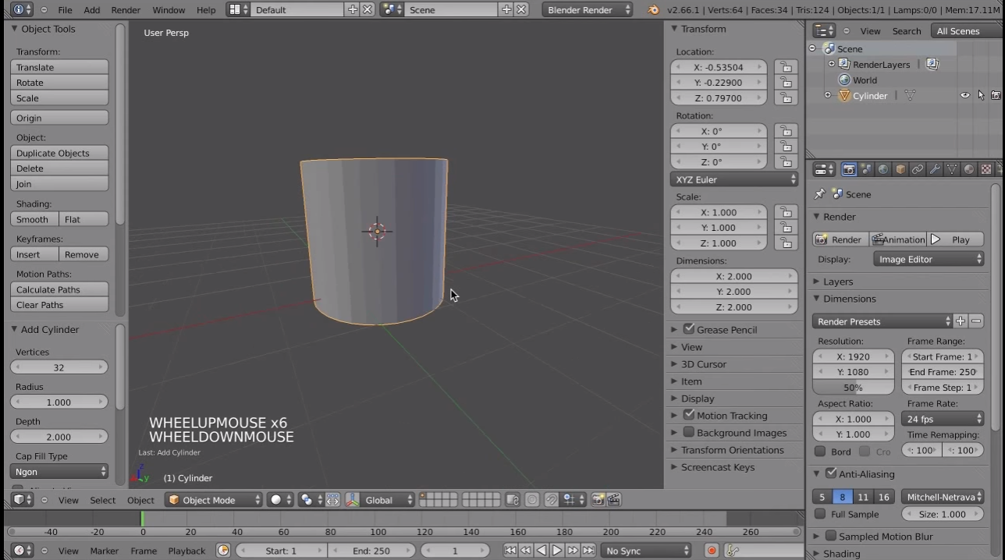

3D Viewport

Viewport Properties (toggle with P)

Toolbar (toggle with T)

Lower Viewport Options

Operator Panel (context-sensitive)

Timeline

Information Bar

Render Engine Selection

Screen Layout Selection

Scene Information (edge count, etc.)

Object Outliner

Properties Panel

Primitive Mesh Object

View Mode

3D Cursor