Advanced Photography: Stuff You Should Know

Depth of Field: The zone of foreground and background within a photo that will appear in sharp focus. In every photo, there is a certain area of your image in front of and behind your subject that will appear in focus.
- Deep Depth of Field = More Scene is in Focus = Sharp Foreground & Background
- Shallow Depth of Field = Less Scene is in Focus = Sharp Foreground, Blurry Background

Aperture: There is a hole within the lens that expands and retracts. The size of the opening is the aperture, and when you control the aperture, you determine how large or small the opening is. The larger or smaller the hole, the more or less light is allowed in.
- Large Aperture (wide open) = Small F-Stop = Shallow Depth of Field (blurred background)
  - Ex. f/2.8 or f/4
- Small Aperture (stopped down) = Large F-Stop = Deep Depth of Field (sharp fore and background)
  - Ex. f/11 or f/22

Shutter Speed: There is a screen within the lens that opens and closes. How quickly this screen opens and closes is the shutter speed, and when you control the shutter speed you control how long the camera is letting light in. A low shutter speed will require a tripod to prevent camera shake.
- High Shutter Speed = High Fraction = Less Light & Faster Image Capture
  - Ex. 1/1000 or 1000 or 1/1200
- Low Shutter Speed = Low Fraction = More Light & Slower Image Capture
  - Ex. 1/30 or 1/60

ISO: The camera’s sensitivity to light. The higher the ISO, the harder your camera has to work to gather light and because of this, images can sometimes look grainy (aka noisy).
- High ISO = High Number = More Light Sensitivity
  - Allows for faster shutter speeds & smaller apertures
  - Increases the chances of having a noisy image
  - Ex. 800 or 1200
- Low ISO = Low Number = Less Light Sensitivity
  - Requires slower shutter speeds & larger apertures
  - Reduces the chances of having a noisy image
  - Ex. 100 or 400

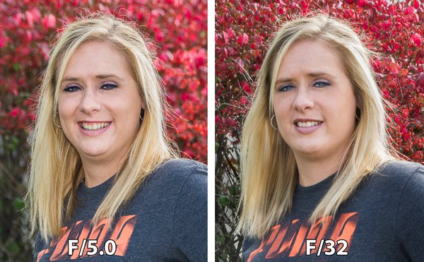

Portrait Photography
…is photography of an individual person/group of people that displays the personality, expression, interests, or mood of the subject. The focus of the shot is usually placed on the subject(s)’ face, though the entire body might be included, as well. In portraiture, you should seek to maximize your photographs by staging your shots. Act as a writer composing a story about your subject, and the director calling the shots that will best make this story come to life.

You must submit a total of 3 portraits for assessment. 1/3 MUST be of the following combination: Posed-Medium-EyeLevel-SingleSubject, as this is the classic form of portrait photography. For your other two, you may choose any combination of the shot types listed below. For each photo you take, choose a criteria from each of the 4 categories.
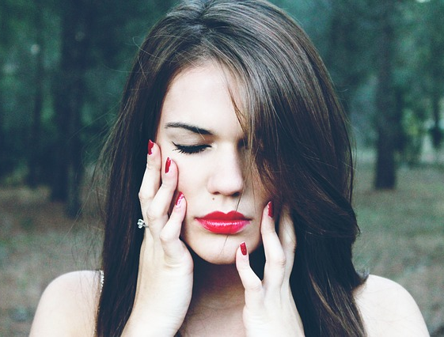
Shot Types
1) Type of Subject
- Posed Shot
- Candid Shot
2) Framing of Shot
- Wide Shot
- Long Shot
- Medium Shot
- Close-Up Shot
- Extreme Close-Up Shot
3) Angle of Shot
- Tilt Shot
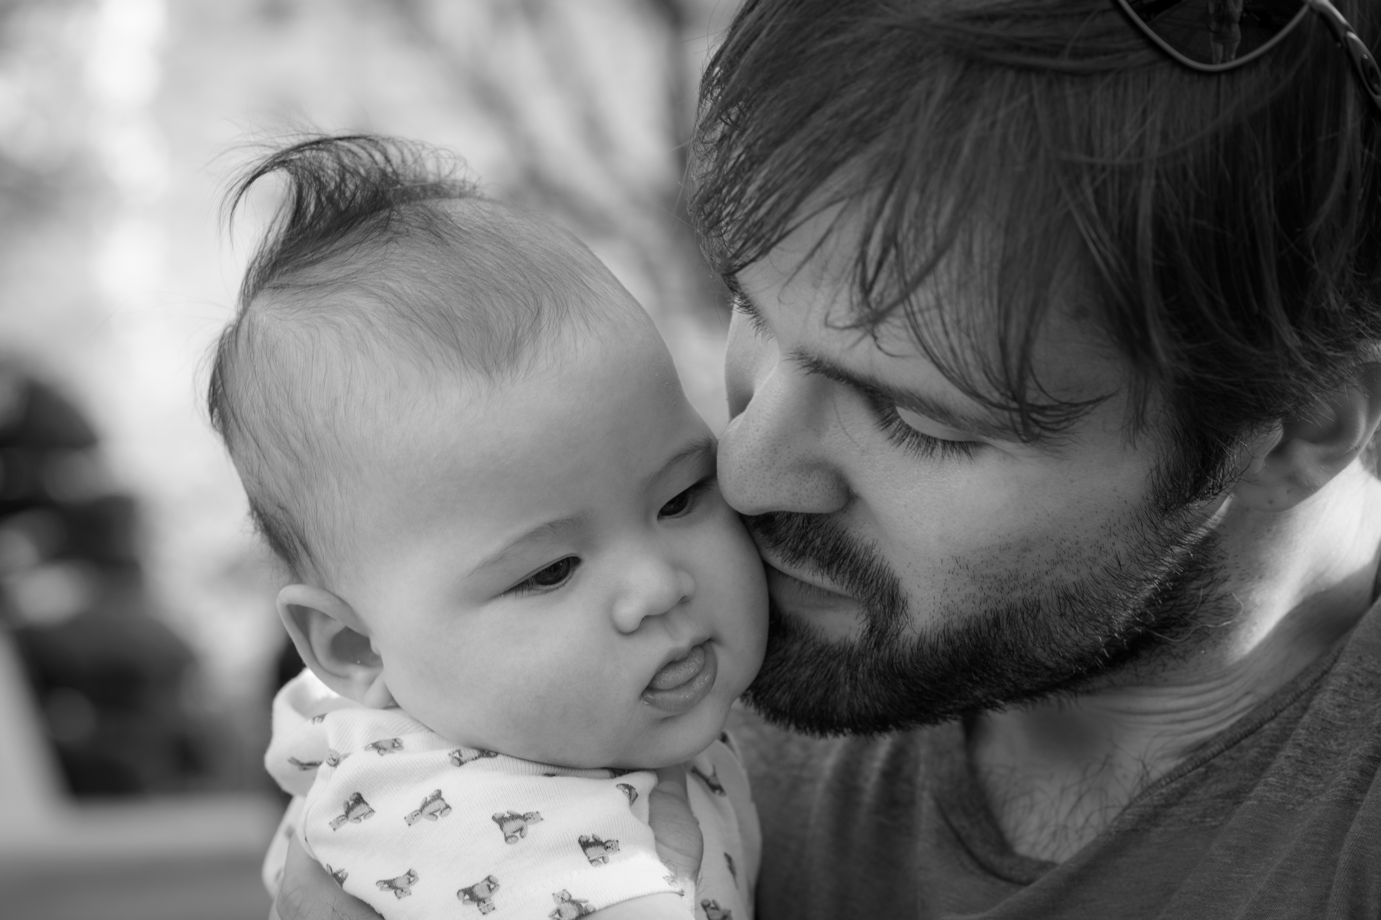
- Low-Angle Shot
- High-Angle Shot
- Eye-Level Shot
4) Number of Subjects
- Single-Subject Shot
- Group Shot
- Two-Subject Shot
- Subject-Object Shot

Portrait Photography Tips
Composition Techniques
- Neutral, understated background
- Subject faces the camera at a 45 degree angle
- Fill the frame – your subject is the only part of your picture that matters
- Rule of Thirds – either frame your subject so that a part of his/her body touches each of the four intersections (thus being centered), or two of the four intersections
- Pose your subject’s body (esp. the hands), location, and facial expression to look natural
- Help your subject feel at ease
Focus – focus your camera on your subject’s eye(s)
Depth of Field – create a shallow depth of field
- Small distance between camera and subject, large distance between subject and background
- Aperture: large aperture (small f-stop number)
- Shutter Speed: high shutter speed
- Change your camera SCN setting to Portrait Mode (and it will adjust these settings for you) or Aperture Priority Mode (and it will adjust shutter speed and ISO for you while allowing you to adjust the aperture)
Lighting – soft, natural light (outdoors or window) during daytime hours or bright indoor lighting is best; avoid using flash if possible

Macro Photography
…is photography of an individual object that makes it appear larger than life size. The most defining feature of macro photography is a highly focused subject that stands out against a blurred background. Some common subjects of macro photography are plants, leaves, insects, rain drops, snowflakes, beverages, etc., but you may choose any subject you like. The focus of the shot is usually placed on the subject(s)’ face or front, though the entire body might be included, as well. In macro photography, you should seek to maximize your photographs by selecting subjects that will be made either more interesting, or more beautiful when examined up close.

You must submit a total of 3 macro images for assessment. Each photograph must contain a different subject or object.

Macro Photography Tips
Composition Techniques
- Neutral, understated background
- Subject faces the camera at any angle (experiment with eye-level, high, low, tilts)
- Fill the frame – your subject is the only part of your picture that matters
- Rule of Thirds – either frame your subject so that a part of his/her body touches each of the four intersections (thus being centered), or two of the four intersections
Focus – focus your camera on your subject’s eye(s) or center
Depth of Field – create a shallow depth of field
- Very small distance between camera and subject, relatively large distance between subject and background
- Aperture: large aperture (small f-stop number)
- Shutter Speed: high shutter speed
- Change your camera SCN setting to Macro Mode, which is sometimes hidden inside Portrait Mode (and it will adjust these settings for you) or Aperture Priority Mode (and it will adjust shutter speed and ISO for you while allowing you to adjust the aperture)
Lighting – soft, natural light (outdoors or window) during daytime hours or bright indoor lighting is best; avoid using flash if possible
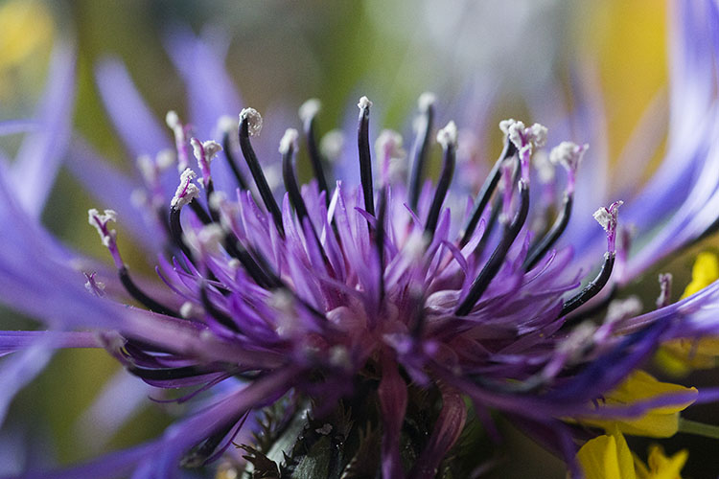

Landscape Photography
…is photography that shows the various landscapes within our world, including both natural and man-made. Popular landscapes include mountains, fields, rivers, cityscapes, and architecture. In landscape photography, you should seek to maximize your photographs by selecting landscapes that tell a story about its history, nature, wildlife, or human inhabitants. What makes landscape photos worth taking is often their beauty, but this does not have to be the case. There are many aspects of the world’s landscapes that are less glamorous, such as the effects of environmental wear and tear, or human degradation that make for captivating photographs for the concerned photographer.

You must submit a total of 3 landscape photographs for assessment. 2/3 of these photos must demonstrate sharp focus throughout the entire landscape. 1/3 photos should demonstrate either the foreground or background in sharper focus than the background/foreground, respectively.
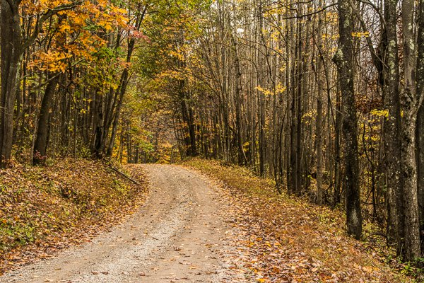

Landscape Photography Tips
Shot Type
- Wide Shot
- Neutral, Low or High Angle
Composition Techniques
- Both background and foreground are typically in sharp focus
- Camera faces the landscape head-on
- Rule of Thirds – frame your landscape so that the most interesting points align with the four intersections (ex. the horizon lines align with the two lower intersections, or the tallest building aligns with the top right intersection)
- Framing – Landscapes are often filled with natural (or manmade) angles and lines. Make use of these lines to help you frame the most important parts of your photo.
Focus – focus your camera on the most interesting point in the landscape; if there is no one interesting point, focus on the lower third of your scene to ensure it is in sharpest focus. You may want to try focusing on the upper third of your scene as well, to try to produce a foreground blur.
Depth of Field – create a deep depth of field
- Large distance between camera and subject, small distance between subject and background (if possible)
- Aperture: small aperture (large f-stop number)
- Shutter Speed: low shutter speed
- Change your camera SCN setting to Landscape Mode (and it will adjust these settings for you) or Aperture Priority Mode (and it will adjust shutter speed and ISO for you while allowing you to adjust the aperture)
Tripods & Surfaces – Generally, the smaller your aperture, the lower your shutter speed… the lower your shutter speed, the longer the shutter stays open to capture the scene. This means that your camera is more susceptible to camera shake and motion blur. This means that you should use a tripod, or find some other way to balance your camera.
Lighting – soft, natural light (outdoors) during daytime hours or bright indoor lighting is best; avoid using flash if possible

Action Photography
…is photography in which the subject(s) are in motion. Popular action shots depict animals in their natural habitats, humans participating in sports, or vehicles in transit. Action photography is one of the most difficult types because photos must be taken at exactly the correct time to lock focus, and capture the motion at its highest peak of interest. Not only should our subjects be crisp and clear, but we must make it obvious that they are in motion, and tell the story of that motion.

You must submit a total of 3 action shots for assessment. 1/3 MUST be of the following combination: Candid-Long-EyeLevel-SubjectObject, as this is the classic form of action photography. For your other two, you may choose any combination of the shot types listed below. For each photo you take, choose a criteria from each of the 4 categories. I recommend trying medium or close-up shots to show the athlete’s facial expression.
Shot Types
1) Type of Subject
- Posed Shot
- Candid Shot
2) Framing of Shot
- Wide Shot
- Long Shot
- Medium Shot
- Close-Up Shot
- Extreme Close-Up Shot
3) Angle of Shot
- Tilt Shot
- Low-Angle Shot
- High-Angle Shot
- Eye-Level Shot
4) Number of Subjects
- Single-Subject Shot
- Group Shot
- Two-Subject Shot
- Subject-Object Shot

Action Photography Tips
Composition Techniques
- Neutral, understated background
- Angles – experimentation is extremely important since we must be creative to show that our subjects are in various types of motion, rather than stationary
- Fill the frame – your subject(s) are the only part of your picture that matters
- Positions of Action – capture your subject when they are in a position of action, rather than rest (ex. if you capture a runner, take the photo at a stage in her run cycle where she is leaning forward, rather than upright).
- Quantity – take LOTS of photos; it is tough to time the perfect action shot – the more photos you take, the better your chances of capturing a great photo
Focus – focus your camera on your subject’s eye(s) or back of their head (if facing away)
Depth of Field – create a shallow depth of field
- Small distance between camera and subject, large distance between subject and background
- Aperture: large aperture (small f-stop number)
- Shutter Speed: high shutter speed (although, to create motion blur use lower shutter speeds)
- Change your camera SCN setting to Action or Pets/Kids Mode (and it will adjust these settings for you) or Shutter Speed Priority Mode (and it will adjust aperture and ISO for you while allowing you to adjust the aperture)
Lighting – soft, natural light (outdoors or window) during daytime hours or bright indoor lighting is best; avoid using flash if possible

