Animalize ME Assignment
An Introduction to Compositing in Photoshop

What do I need to do?
For this assignment, you will be compositing a portrait of yourself… below a portrait of an animal (of your choice) to make it look like you are some sort of exotic hybrid creature roaming the jungles in the deepest nooks of the world.

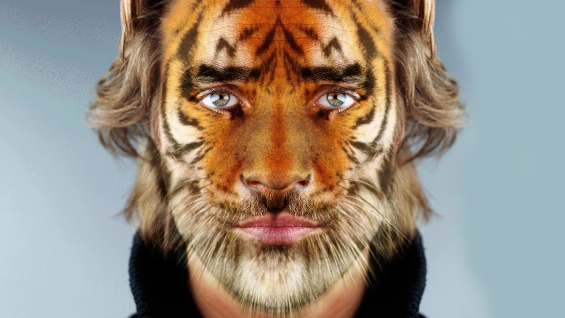
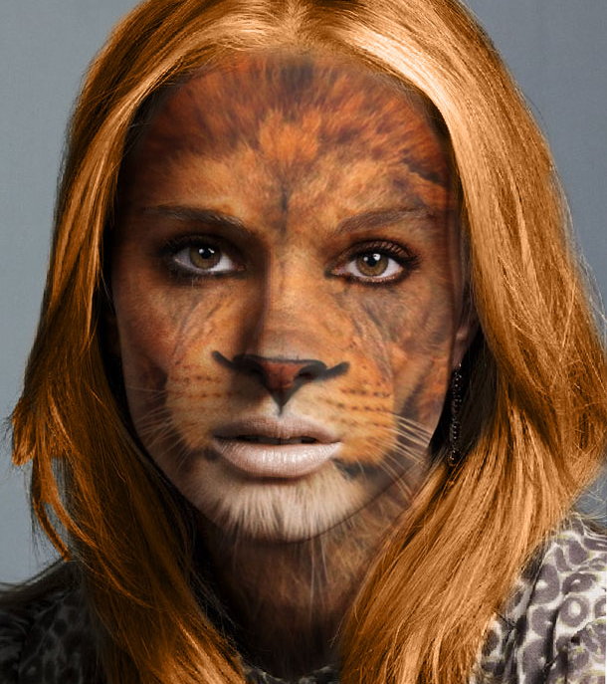

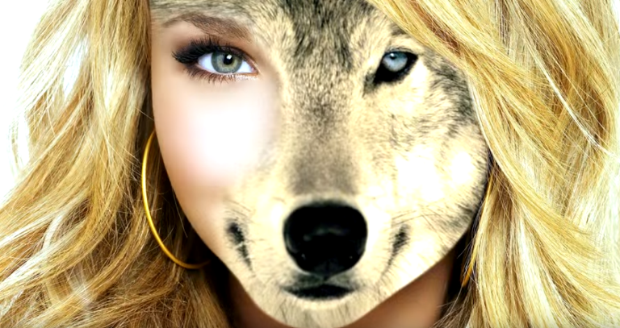

Where do I put the files I use for this assignment?
Create a new folder inside your Photoshop folder called “loginname_Animalize.”

What if I need extra help?
Ask me, ask your peers, ask the internet. This assignment was based off of the following YouTube tutorial by Blue Lightning. It is a good tutorial – but the version of Photoshop the tutorialist (yeah I made that word up – so what?) uses is out of date, and he includes several steps (such as saving selections and creating a displacement map) that aren’t totally necessary.
- https://www.youtube.com/watch?v=L0882SY76W8

What type of portrait can I use for this assignment?
A close-up shot of yourself looking directly at the camera (not on an angle). It is important that the shot was taken as a close-up that contains (at max.) your shoulders and up, or (at min.) your face only. This will guarantee the highest possible resolution for your image. If you already have a photo like this, go ahead and use it. If you don’t, have a partner take one for you.

How will I find my animal photo?
In the Shared > Hammond > Handout folder, you will find a folder called “Animalize-Animals.” Inside this folder you will find a variety of medium-large high resolution photos you may use for this assignment (recommended). You are also welcome to try to find your own – just make sure that the image is large (1000x1000 pixels-ish, at least) and that the photo is a close-up of the animal’s face, looking directly at the camera.

How will I make the animal’s face the same size as my face?
Place your animal’s face over top of your own face (on 2 separate layers). Reduce the opacity of the animal’s face to somewhere between 30-50% so that you can see your face underneath. Resize the animal image so that it is approximately the same size as your face, then place the animal’s face atop yours so that the noses line up together. To remove any “extra” pieces of the photo that do not align with your face, use the Quick selection, Magnetic Lasso selection, or Lasso selection to make a selection of your animal’s face that roughly matches the size of your own face (it does not need to be perfect – you can adjust it later). Click on the “Select and Mask” button in your options panel to refine your selection and output it to a Layer Mask. Remember, you can always select the Layer Mask icon and use a black paintbrush o conceal, and a white paintbrush to reveal.

How will I adjust my photo so that my animal’s features match my features?
With your animal layer selected, click on Edit > Transform > Warp, then select the Warp tool from the options panel to divide your image up into a grid. Begin pulling the points along the grid to warp the animal’s features so that they match your own (your opacity will still need to be reduced to 30-50% in order to do this). Your eyes should match up with your animal’s eyes, your nose with its nose, your mouth with its mouth, your hairline with its hairline, etc.

How will I “combine” my features with my animal’s features?
In your Layer’s Panel, increase the opacity of your animal layer back to 100%, and change the animal layer’s Blend Mode to Multiply (this will make the darker pixels in both layers darker, and the lighter ones lighter to give the effect of “combining” the layers). Click on the animal layer’s Layer Mask icon, then use a white brush (change the opacity of the brush to somewhere between 50-80% to create a blending effect) to reveal your eyes, lips, eyebrows, etc. from beneath the animal face.

What other touches can I add to make it look more realistic?
Use some of the other skills you’ve acquired throughout the semester and feel free to experiment with some of your own. Some suggestions:
- Use the spot healing brush to remove unwanted features or patterns from your animal’s face or from your own face
- Brush out “accessory” parts of your animal’s face (ears, whiskers, chin hair, neck fur etc.) in your layer mask to make yourself even more animalized
- Use the burn/dodge tools to lighten or darken certain areas of your face/animal’s face to make the animal’s features stand out more
- Use a brush set to hue/colour mode to change the colour of your hair or skin to better match the colour palette of your animal

How do I hand it in?
Save a .PSD and .JPEG copy of your assignment to your “loginname_Animalize” folder. Also place the original images of your face and your animal’s face inside this folder (for a total of 4 documents). Hand it in to the appropriate Shared> Hammond > Hand In folder!

