Animoto Instructions

Signing Up

- Visit https://animoto.com/ (ctrl + clicking the link will take you there)!

- Click “Sign Up” in the upper-right corner!

- Fill out the sign-up form with your information. For your email address, use your bpsdedu account (aka your school email). If you don’t know what yours is, or you haven’t used it before, it will be the first initial of your first name followed by your last name @bpsdedu.com (example: Brittani Hammond’s email would be bhammond@bpsdedu.com)! Make sure to remember your password you choose for your Animoto account – if you are forgetful, write it down somewhere safe.

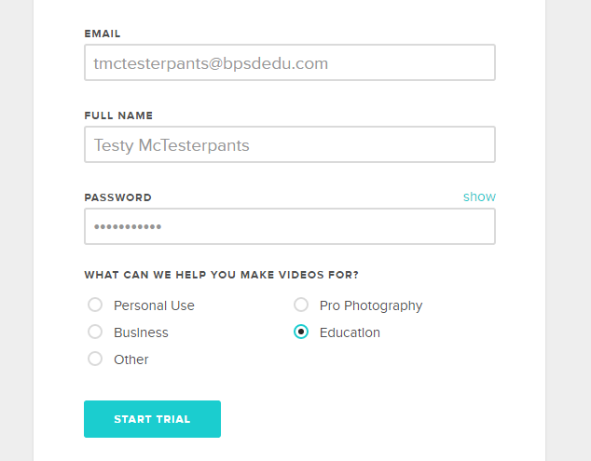

- Click on the START TRIAL button.

Entering the Education Account Code
- In the black margin on the left side of your screen, click on “Account.”
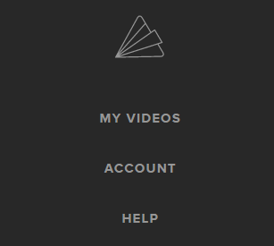
- On the right side of your page, you should see a spot where you can “Redeem a promo code.” Copy and paste the following promo code into the “Enter Code” bar, then click “SUBMIT CODE.” Promo Code: a4emctefea00fe2a56e4286 Pasting this educational code will give you access to more of Animoto’s features! You must use this code if you want to download your video later.
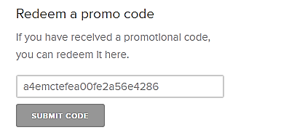
- If you successfully pasted the code, the following message should appear at the top of your screen:
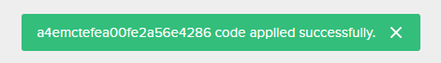
- In the black margin on the left side of your screen, click the paper plane icon to go back to the dashboard. Any time you wish to return to the dashboard, find the paper plane logo (FYI: sometimes it is rainbow-coloured and at the top of your page!)

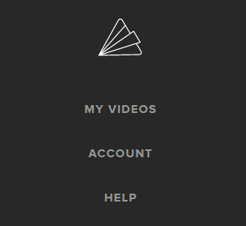

Creating Your Storytelling Montage
- Watch the brief Getting Started video by ctrl + clicking on the blue link.
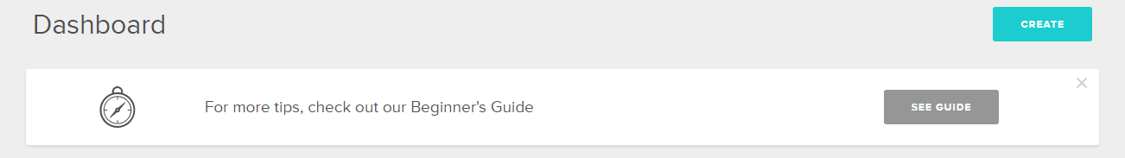
- When you’re ready, click on the blue “CREATE” button in the top-right corner of your Animoto dashboard to begin creating your storytelling montage! If you get lost, you can always go back and re-watch the video – or, ask the person next to you for help! You may also choose to take the guided tour that pops up after you choose your style.

- Remember – Assignment Requirements: Your video must contain 15-20 photos, music (use Animoto’s free, built-in tunes), and a title and end slide. It must be under 90 seconds in length, and tell a clear, creative story (without using any words)! Your “Total video length” will show up in the top-left corner of your screen. PS: You cannot use any of the styles with a “PRO” watermark in the corner – those cost $$$.

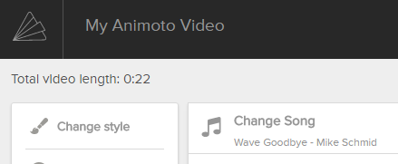
- FYI – Video Length: To change the length of your video (pacing) or audio, click the little gear icon in the top-right corner!
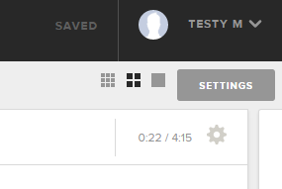
Downloading Your Video
- FYI – Your video will save automatically!

- When you are finished building your Animoto storytelling montage, click on “PRODUCE” at the top of your screen.

- Fill in any missing blanks (title, date, description) on the next screen, then click the blue “FINISH” button at the bottom of the page.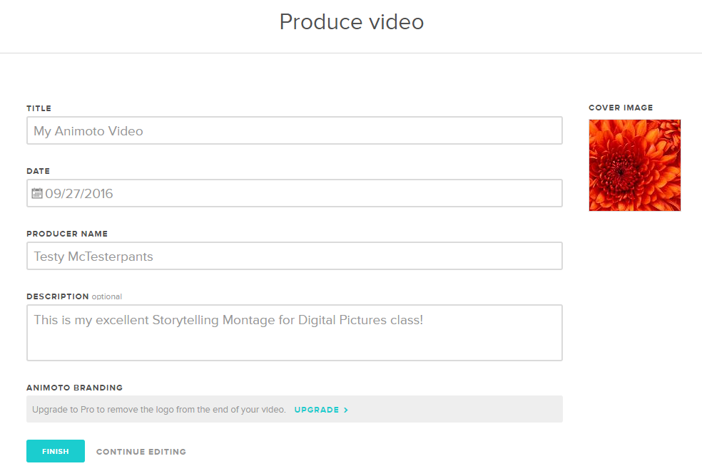

- Wait for your video to finish “finalizing” (see bottom of video)

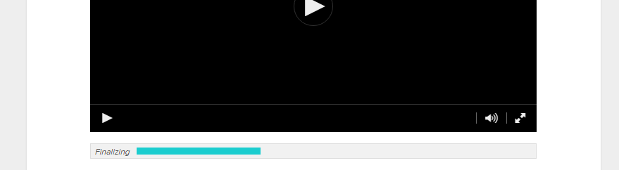

- On the right side of your screen, under “OPTIONS,” click on “Download”
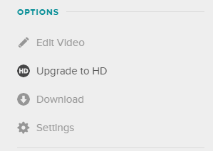
- In the “Video Quality” pop-up, click on the “MP4” button beside 360p (anything higher than this will require you to pay, and we don’t want that).
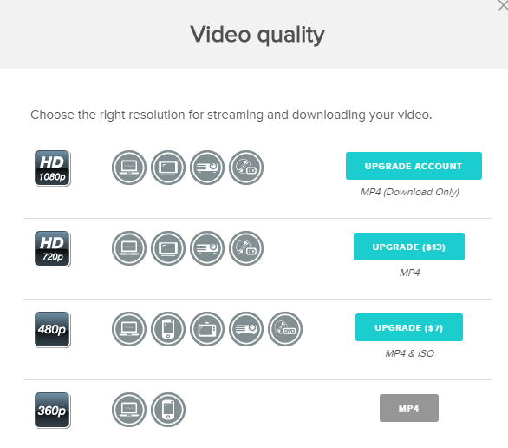
- Your video will download just like the files you download off the class website! So, just like you do with downloads from the class website, cut it out of your downloads folder and paste it into your 2D Animation > Unit 1 – Storytelling folder.

- Rename your file so that your login name at the front of the file name, then hand it in to Shared > Hammond > Hand In > Digital Pictures A/B (depending on which class you are in, of course)

