12 Qualities Employers Look For When They're Hiring
Liz Ryan ,
CONTRIBUTOR
I write about bringing life to work and bringing work to life.

The funny thing about the recruiting process is that if you read job ads, you'd think that employers are strictly looking for people with very specific types of experience. That's all you can see in a job ad -- long lists of bullet points with Essential Requirements like years of experience with certain tools, and obscure industry certifications!
Once you get to a job interview, though, the whole picture changes. Employers are looking for qualities in their new hires that are never listed in the job ad. They want to meet people who are self-directed and responsible. You will bring out those qualities through your answers to the job-interview questions and also through the questions you ask your interview.
The stories you tell on a job interview will bring out your sterling qualities, too. You don't have to talk about your best traits. They will shine through if you let them!
Here are 12 qualities employers look for in their new hires:

Employers want to hire people who...
Understand their own path
You have a path that you've followed since you were born. Can you tell your story in such a way that you make it clear how you've followed an interest or passion of yours to get to the place you stand in right now? Can you talk about your path going forward?
Know what they want in their career
Employers look for 'self-directed' new hires, and here's what that means. They want people who know what they want and are willing to work for it. I met a new grad who told me "I'm interested in starting my own company some day but I expect that to happen some years from now. In the meantime, I want to learn all I can about how a business works. Can I say on a job interview that I hope to be an entrepreneur one day?" "Yes, you can!" I said. "The right managers will appreciate that about you. You have a better reason to pay close attention to whatever business you're working in than a person who has no goals and took the job just to get a paycheck. Great managers want to hire people with goals, like you."

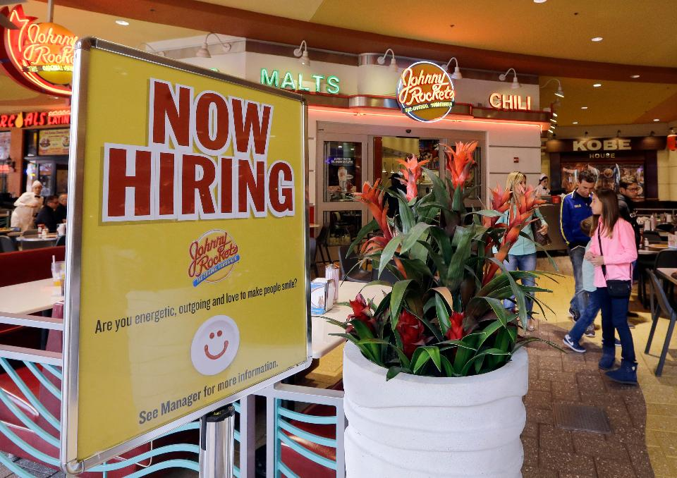
Can point to successes at work or elsewhere

When someone asks you "Can you tell me a story about a time when you felt triumphant?" what stories from your past spring to mind? You've got to be able to talk about your successes. You don't have to have competed in the Olympics or climbed Mt. Everest. You can tell simple stories about saving the day at work or in a volunteer situation or even at home.

Know their strengths
Employers are looking for people who know what they're good at. Instead of saying "I'm really good at Excel," you can say "I love Excel -- and I love to teach other people the finer points of using Excel, like creating nested reports and macros."
Think Independently
There are certainly managers who don't want to hire independent thinkers, but you don't have to waste working for someone like that! Strong managers want to hire people who have their own ideas. In every job interview, take the opportunity to share an opinion, rather than a cookie-cutter, standard answer to your interview question. Managers need smart people around to brainstorm with -- so why shouldn't that smart person be you?
Like to problem-solve
You've solved big problems in your life -- everyone has. They say that before a child goes to kindergarten he or she has already conducted 50,000 physics experiments (often using water, mud and dog food as materials). Tell a story about a problem you solved. Maybe you found a better way to organize something or you improved on a process that didn't make sense. In the best job interviews, your manager will see your brain working and you'll see his or her brain working, too!
Have ambition
Having ambition means you have the goal of getting smarter and stronger throughout your life. It could mean moving up the corporate ladder, starting your own business or going off the grid to something completely new. Good employers look for people with ambition.

Are proactive
Proactive employees don't wait to be told what to do. They jump into action when they see a way to help. Managers want to hire people who are proactive. One way to illustrate this quality is to ask questions about the work you'll be performing in the job (most job applicants, sadly, don't do this). Ask questions that show you've been thinking about the job description -- your new manager will appreciate it!
Are happy to learn new things
Most of us have worked with someone who hates to be bothered to learn new things. Whenever there is something new to learn, that person says "Oh no, not something new! I hate having to change the way I do things." Managers want to hire people who like to learn. If you read in your spare time or follow courses online, say so!
Are goal-oriented
If you like to set goals and hit them, make that clear in your job interview. Talk about how you set a goal to start your own blog and accumulate 100 readers - and how you hit the goal! Talk about how goals have been important in your life so far.
Work well on a team
Nearly every manager will tell you that teamwork is a critical attribute for anybody on his or her team. Be ready to answer the question "Tell me about how you function on a team" with a colorful story about a situation that required teamwork, and in which your team came through!
Are responsible
Lastly, employers want to hire people who take responsibility for themselves and the situations they're in. Talk about the responsibilities you've taken on in your working life and outside. If you were a river-rafting guide in the summers during your college years, say so!
There's a lot of responsibility in a job like that, including responsibility for people's lives! The same is true if you were a nanny. Watching infants and young children is a high-responsibility job. Don't ever be embarrassed or shy about sharing your 'non-business' experience. Sometimes those experiences show our character most of all!
Liz Ryan is CEO/founder of Human Workplace and author of Reinvention Roadmap. Follow her on Twitter and read Forbes columns.

