Multiply Me Assignment
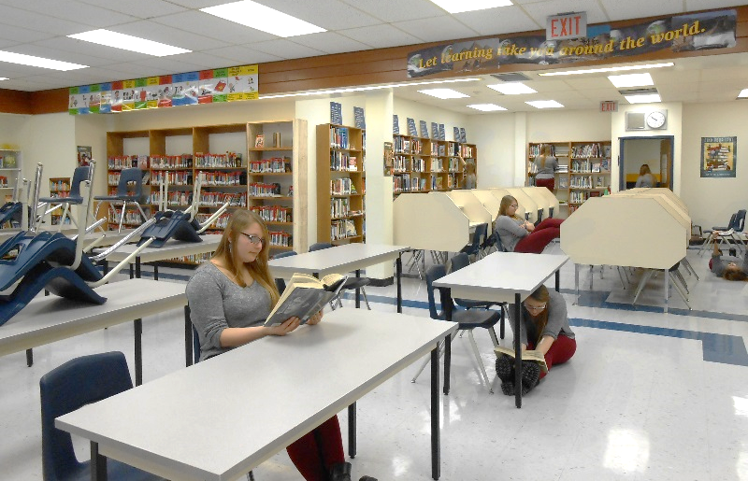
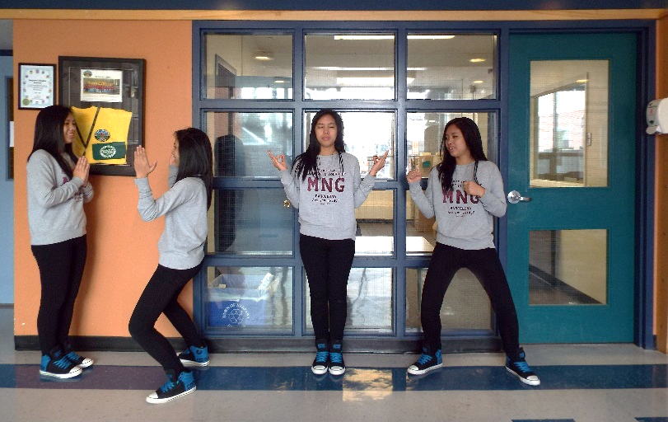

What do I need to do?
Now that you know how make precise selections using Layer Masks, your task is to create a single scene that contains 5-7 YOUs by compositing 5-7 photos into one!

How will I take my photos?
- Group up (with 4-5 people) and grab a tripod (from behind Ms. Hammond’s wooden desk). There are only 5 tripods, so you will have to share.

- Grab a camera (1 per group is fine, so that you don’t have to keep screwing and unscrewing it onto the tripod – you will just need to take turns importing your photos into your computer).

- Find a location either inside or outside the school. Your location should provide MANY creative opportunities for posing, and as much natural lighting as possible (for the best quality photos).

- Set up your tripod by, first, unclipping the snaps on each leg to lower the legs. Once you’ve done this, make sure that all legs are level by checking the simple bubble level on the upper portion of your tripod (the bubble will be in the circle if the tripod is level). Next, place the camera atop the tripod mount (make sure to screw it on tight enough so that it will not fall off, but loose enough that you will be able to get it off when you are done, using your fingers). Use the lever on the side of your tripod to pan up and down, and back and forth until you are happy with what you see through your camera’s viewfinder (LCD preview screen).

- Take your photos. Each member of the group will take turns posing for, and capturing, images. The camera/tripod MUST NOT MOVE while each partner’s pictures are being taken, since a key part of this assignment’s success is that ALL photos of each person have THE EXACT SAME BACKGROUND. When it is your turn to be the model, position yourself in different places and poses throughout your chosen scene (it is okay, and even encouraged to overlap your poses/positions in the scene), as long as they are within the camera’s viewport! It is the group member who is taking the photos’ responsibility to make sure that all your poses are within the camera’s viewfinder. Even though you only NEED 5-7 photos, take 10 so that you have a variety to choose from.

- Create a new folder inside your Photoshop folder called “loginname_multiplyme.” Import your photos into this folder. Take turns importing ONLY the photos of YOURSELF into your computer.

How will I make this assignment in Photoshop?
- Open a new Photoshop Document. Name it “loginname_multiplyme.” Make sure that it is set to 11 inches (width) x 8.5 inches (height), since you took your photos using landscape (hamburger) rather than portrait (hotdog). Make sure that the resolution is set to 300 pixels per inch (print resolution). Save your document inside your “loginname_multiplyme” folder.

- Open each of the 5-7 photos you will be using for this assignment, then drag each into your Photoshop document, so that each is placed on its own layer. Rename each layer so that it reflects each pose.

- Position your layers (by dragging them up/down in the layers panel) so that your models are in the order you want them to be in.

- Begin Layer Masking! You will select and layer mask each (though some photos will need more layer masking than others, depending on where you are located within your photo) of the photo’s backgrounds out EXCEPT for the bottom photo in your layers panel (since you want to keep the full background in at least one photo). If you make a mistake, don’t worry! You can always click on a layer’s black and white “Layer Mask” icon, then use a white paintbrush to reveal, and a black paintbrush to conceal.

How do I hand this in?
Save a copy of your document as a Photoshop (.PSD) file type. Save another as an image (.JPEG) file type. Hand in your entire “loginname_multiplyme” folder (which should contain your .PSD, .JPEG and all photos you used for this assignment) into Ms. Hammond’s hand in folder.

How do I get a good mark on this assignment?
- Be creative in your background and choice of poses
- Make your final product look believable (like there really are multiple yous in one place) through careful, polished and precise selections and layer masking
- Use Layer Masking to remove backgrounds, NOT the eraser or delete key

