Digital Pictures 25s
Teacher: Ms. B. Hammond
Contact Information: bhammond@bpsd.mb.ca
Class Website: www.mshammondsclass.weebly.com
Remind101 Info: Phone Number: 204 800 4184 & Code: @adigipics (a) or bdigipics (b)

Periods 7-8 Semester One Room 206

Course Overview:
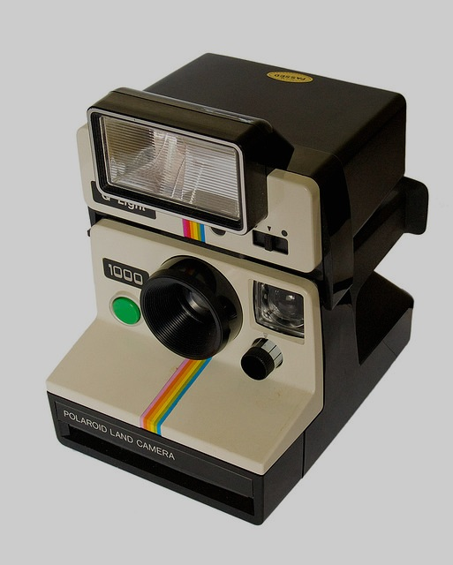
Welcome to Digital Pictures 25S! The purpose of this course is to provide you with the skills and knowledge necessary to understand the messages conveyed through digital pictures, and to plan, produce, and manipulate these messages yourself. In addition to the specific skill of digital picture production, an emphasis will also be placed on more general ICT skills, including inquiry, communication, digital citizenship, evaluation, problem-solving, and teamwork.

Supply List Program List
8GB Flashdrive/USB Stick Adobe Photoshop
Weebly Education
Various Web 2.0 Tools

Classroom Tools & Procedures
It is my goal to run an almost entirely paper-free course. This means two things: 1) You will not need a binder for this course (everything you create will be stored on your website), and 2) There are some important tools and procedures:
- The S Drive: You will hand most of your assignments in to the “Hammond” “Hand in” folder located in this drive
- Ms. Hammond’s Website: You will retrieve most of your assignments, instructions, and missed assignments here
- Remind101: I will send out homework reminders to your cell phone or email using this app (which we will set up together). This is a way communicate outside the classroom without getting personal phone numbers involved.
Classroom Rules & Expectations:
All members of the classroom will…
- Commit to making the classroom a safe space. Therefore:
  - All members of the classroom will be respectful of the opinions, ideas, culture, and overall person of other members of the classroom, whether they agree with them or not.
- Respect their classmates’ right to learn & work within a school environment. Therefore:
  - There will be no talking during instruction, and no distracting behaviour during work time.
- Use technology in a relevant and respectful manner.
  - The use of electronic devices is essential to this course. However, access to them is a privilege and not a right. Therefore, these devices (desktops, cameras, cell phones, etc.) must be used only for academic purposes during class time (and not at all during instruction), or this privilege will be taken away.
  - MUSIC – Independent work = 1 earbud in, 1 earbud out, Instruction = 0 earbuds in, 2 earbuds out
- Come prepared for class by bringing any tools and materials necessary for class, and saving your work.
  - Students must bring their flashdrives/USB sticks to class every day.
  - Students are also responsible for saving their work frequently, and in multiple places. If any work is lost or is not saved, it is the student’s responsibility to redo this work outside of class time.

Assessment Guidelines:
- Assignments are due at the beginning of class on the predetermined due date.
  - If this is a problem, you are expected to discuss this with me ahead of time.
- Late assignments will receive a zero until the assignment is handed in.
  - If assignments are continually handed in late, a parent-teacher-student conference will occur.
  - Once a unit of study has been completed, you may no longer hand in assignments for that unit.
- Plagiarized assignments will receive a zero until the assignment is redone and resubmitted, and will warrant a serious discussion with Ms. Hammond, your parents, and possibly administration.
- Bombed assignments may be redone and resubmitted…as long as the original copy was submitted on the original due date. If you are willing to put in the effort, I am willing to help you succeed.
- If you miss a class or come in late, it is your responsibility to find out what you missed and access the materials. I will keep them archived on the class website.

Course Learning Outcomes:
- Define the purpose and audience for an image
- Use images to communicate messages
- Capture still images with a digital camera
- Manipulate a digital image to create a new image
- Critique and be critiqued in terms of improvements for an image, given technical and aesthetic criteria
- Understand and select the graphic file format best suited to the end product
*For more information visit: http://www.edu.gov.mb.ca/k12/cur/ict/framework.pd

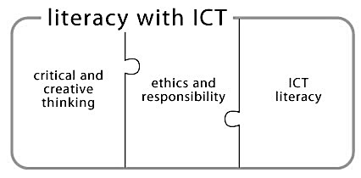

Course Overview
Digital Curation & Design Basics (1 week, ongoing) 10% of Course Grade
Throughout the entirety of this course, students will maintain their very own Weebly website. Students will take part in various lessons on the purpose of a digital curation, how to use Weebly, as well as the design basics that will dictate the design of their digital portfolio, as well as their future photos. Assignments may include:
- Digital Portfolio 100%
  - Curation, Organization, Design & Reflection

Digital Storytelling & The Use of Pictures in Everyday Life (1 week) 20% of Course Grade
Students will study the history and evolution of photography, its personal and industrial uses, and how pictures are used to tell stories and communicate ideas. To demonstrate their understanding of these ideas, students will identify the writing variables for photographs presented in class. They will also be required to choose a photograph and tell the story that lies behind it. Assignments may include:
- History of Photography Powerpoint Slide 10%
- “A Picture is Worth 1000 Words” Assignment 30%
- Storytelling Montage: Animoto Slideshow 60%

The Basics of Photography (3 weeks) 30% of Course Grade
During this unit students will study the history of photography, various file formats, the operation of digital cameras, the types of photography, and the principles of layout and lighting. They will be exposed to a variety of photographs taken by expert photographers, which they will study and critique in order to learn the basic principles of photography. Then students will practice using the techniques they’ve studied while taking their own various types of photographs, learning how to operate a variety of digital cameras along the way! Assignments may include:
- “What is a Digital Picture” Test 10%
- Composition Basics 1 Assignment 25%
- Composition Basics 2 Assignment 25%
- “4 Types of Photos” Assignment 40%

The Basics of Photoshop (4 weeks) 40% of Course Grade
Adobe Photoshop is an extremely powerful tool that provides its users with endless possibilities when it comes to photo manipulation. This unit will attempt to scratch only the surface of this program. Over the course of this unit, students will begin by learning the more basic functions of Photoshop, including the interface, filters and effects, functional photo retouching, and end with a firm foundation in compositing. The tutorials throughout the unit will equip students with the skills they need to succeed in a step-by-step, hands-on way. The more heavily-weighted assignments will allow them to apply these skills in new, creative ways that speak to who they are as digital artists. Assignments may include:
- The Sandwich Tutorial 05%
- Urban Playground Tutorial 05%
- Photo Editing Scavenger Hunt Assignment 10%
- Digital Donut Tutorial 05%
- Multiply Me Assignment 10%
- Animalize Yourself Tutorial 05%
- Collage or Montage Assignment 60%

Final Note for Students:
It is no secret that I am relatively new to the world of ICT, as I have been an English teacher in previous years. However, I look forward to working together as we continue to learn about Digital Pictures, which I know will grow to be one of my favorite subjects (and I hope yours, as well). I want you to know that, above all, I am dedicated to helping you succeed in this class, and will do my very best to make myself available during noon hours and after school, should you need any assistance outside of class. If you are a social savant, extra-curricular extraordinaire, or plain ol’ workaholic, and you don’t have time to meet, DO NOT be afraid to shoot me an email or shoot up your hand in class. Best wishes heading into Digital Pictures 25S – here’s to a fantastic semester!

Final Note for Parents:
I look forward to working with your teen, and helping to explore his/her identity, goals, and creativity. Just as I welcome your son or daughter to be a part of the classroom community, I welcome you as well! I encourage you to call, email, or stop by the classroom as much as you like. If you have any questions, comments, or concerns – however large or small – please, do not hesitate to contact me. On that note, it is important for me to provide you with progress reports, and email is an easy way to do this. If possible, please provide me with your email address in the section below. If you do not have an email address, I will keep you updated via phone or standard mail.

After BOTH you AND your parents have read through this course outline:
- Throw down your signatures.
- Rip this sheet off the course outline.
- Hand it in to me for a chance to win a SWEET PRIZE.

I have read the Digital Pictures 25S course outline and am familiar with its contents. I have reviewed the classroom rules and expectations and am prepared to participate in a positive way according to these rules and expectations. I understand that this is a classroom contract and will try my best uphold it.

Date Read: ______________________________________________________________

Student’s name: __________________________________________________________
Student’s signature: _______________________________________________________

Parent/Guardian’s name(s): ________________________________________________
Parent/Guardian’s signature(s): _____________________________________________
Parent/Guardian’s Email Address: ____________________________________________

Any initial comments or concerns: ___________________________________________________________________________________
____________________________________________________________________________________________________________________
____________________________________________________________________________________________________________________
____________________________________________________________________________________________________________________

