The Digital Donut Shop
Design a print advertisement for your donut shop
Tutorial 1: Drawing, Layer FX & Layer Organization

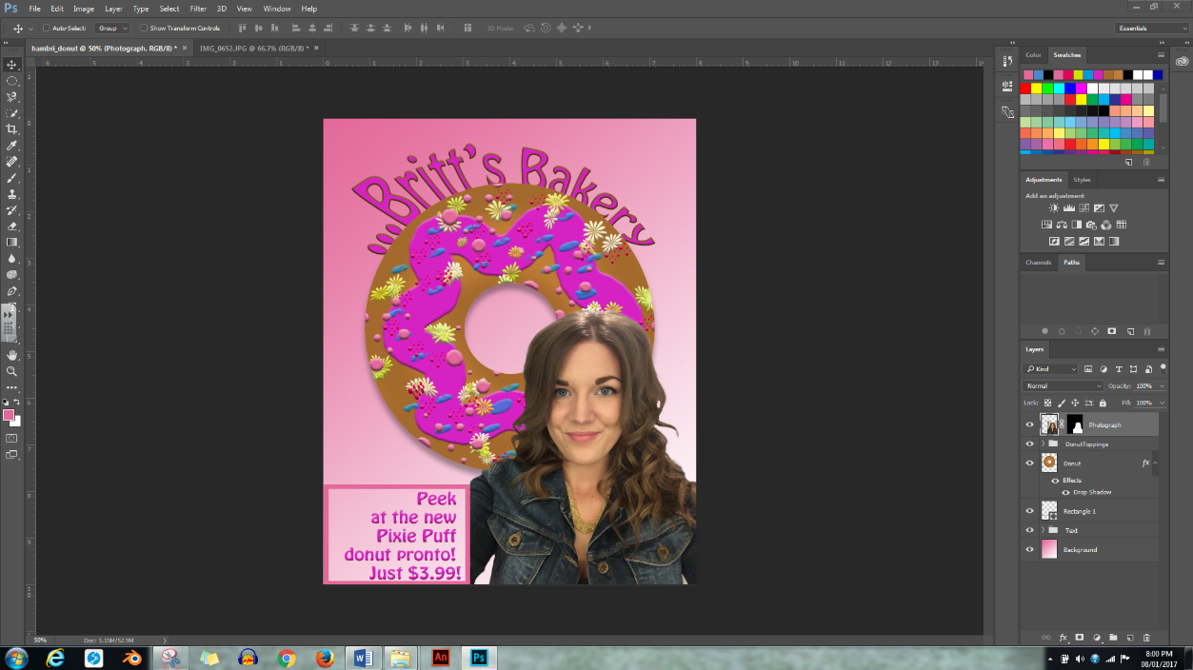

------------------------------------------------------------------------------------------------------------------------------
Part 1: Set Up the Document

- Create a new folder inside your Desktop Publishing folder; name it “loginname_Donut.”

- Create a new Photoshop document: Go to the Menu Bar, then select File > New. Create a document that is 8x10 inches, RGB, 300 pixels per inch resolution
  - Since we would be printing this, it needs to have print resolution

- Save your document inside your “loginname_donut” folder: Go to the Menu Bar, then select File > Save As… and title it “loginname_Donut” Leave the default File Type (.psd)

- Add a New Layer: Click on the “New Layer” icon at the bottom of the Layers Panel. Rename this layer “Donut.”
  - It is very important to name your layers something that identifies the layer’s content – it will make your life much easier down the road

- Add Rulers: Go to the Menu Bar and select View > Fit on Screen, then View > Rulers.
  - Make sure that your Ruler Units are set to “inches” by going to the Menu Bar and selecting Edit > Preferences > Units & Rulers

- Add Guides: With the Donut layer selected, in your Document Window, click on the top ruler and drag down (from the top) to pull Guides to the 3.5, 4.5, 5.5 inch marks along the side. Click on the side ruler and drag over (from the left) to pull Guides to the 3, 4, 5 inch marks along the top.

Part 2: Draw the Donut

- Elliptical Marquee Selection Tool: Go to the Tool Bar and select the Elliptical Marquee Selection Tool. You may need to right-click on the tool to bring up this hidden option. Look at the Options Bar to make sure that the first (“New Selection) option is selected.

- Draw the Donut: Hold your mouse cursor on the center crosshairs, hold down the Alt and shift keys on your keyboard, then click and drag to make the outer shape of your donut. It should take up a fair amount of your document.
  - Holding down the Alt key causes the circle to open from the center, as it normally opens from the edge; holding down the Shift key keeps your circle symmetrical

- Draw the Donut Hole: Go to the Options Bar to make sure that the third (“Subtract from Selection”) option is selected. This time, hold your cursor on the outer-most, upper-left crosshairs. Click and drag the elliptical selection to the outer-most, lower-right crosshairs. You should now see “marching ants” in the shape of a donut Save.

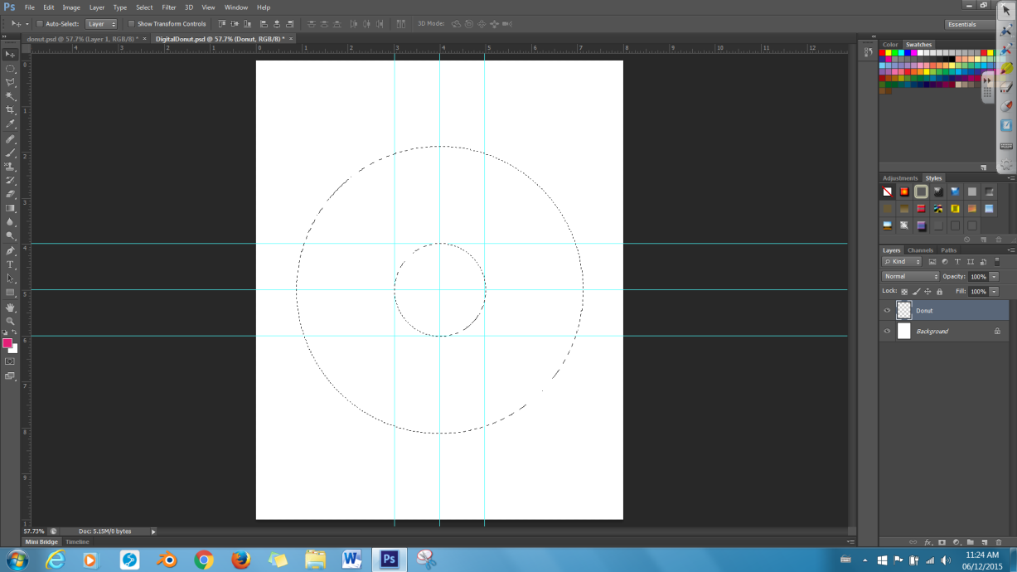

------------------------------------------------------------------------------------------------------------------------------
Part 3: Colour the Donut

- Select the Tools: Go to the Tools Bar, and select the Brush Tool. Under the Options Bar, select a 200-pixel, feathered (soft edges) brush (this will create an air-brushed effect). Using either the Swatches Panel, or the Foreground Colour Tool, choose a light-brown colour to paint your donut.

- Paint the Donut: Paint your entire “donut” within the selection a light brown colour.
  - Notice how the Selection makes it impossible to “colour outside the lines.”

- Add Dimension: Select a slightly darker colour to colour the inside and outside edges of your donut. The top of a donut is lighter because it gets the most light – as you go towards the hole, light is blocked, so to make your donut look 3-dimensional and realistic, you must use also use darker colours to show form).

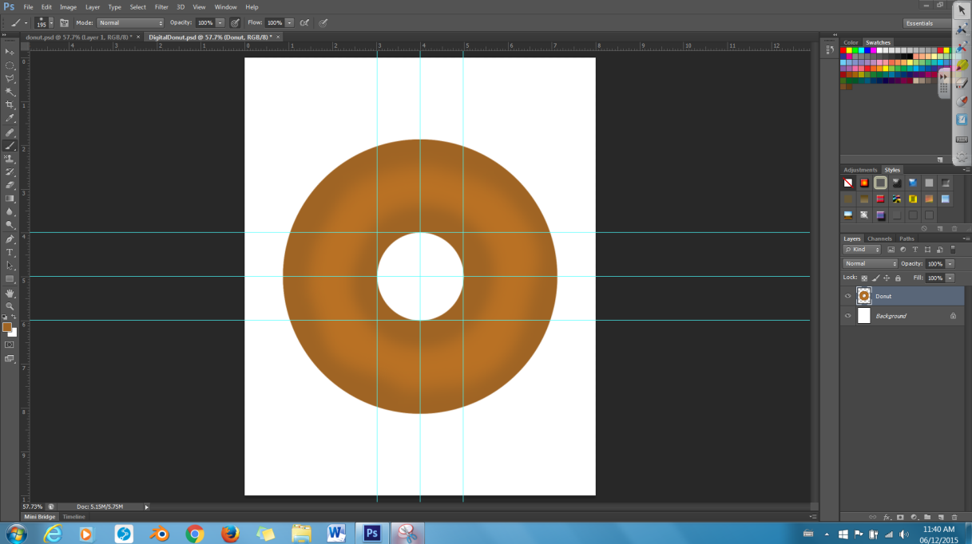

------------------------------------------------------------------------------------------------------------------------------
Part 4: Decorate The Donut

- Create a New Layer: Rename this layer “Icing”

- Add Icing: Select the Brush Tool. Go to the Options bar and select a hard-edge brush. Select the colour you would like to use for your donut’s icing. Make an “icing mark” around the top of your donut.

- Bevel & Emboss: To make your icing more 3-dimensional, go to the bottom of the Layers Panel, and select the Layer FX Icon (2nd from the left). Select Bevel & Emboss, and when the options panel pops up, change the size to somewhere between 5-10

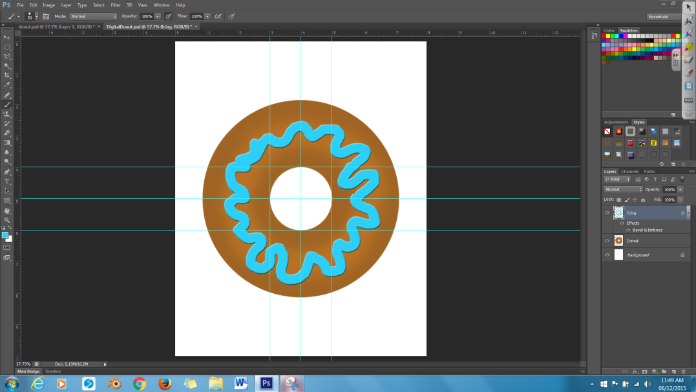

- Add Toppings: Repeat the steps listed above to add 2-3 New Layers, each containing a different topping (ex. sprinkles, confetti, different coloured icing). For each topping, play around with colour, and brush type.

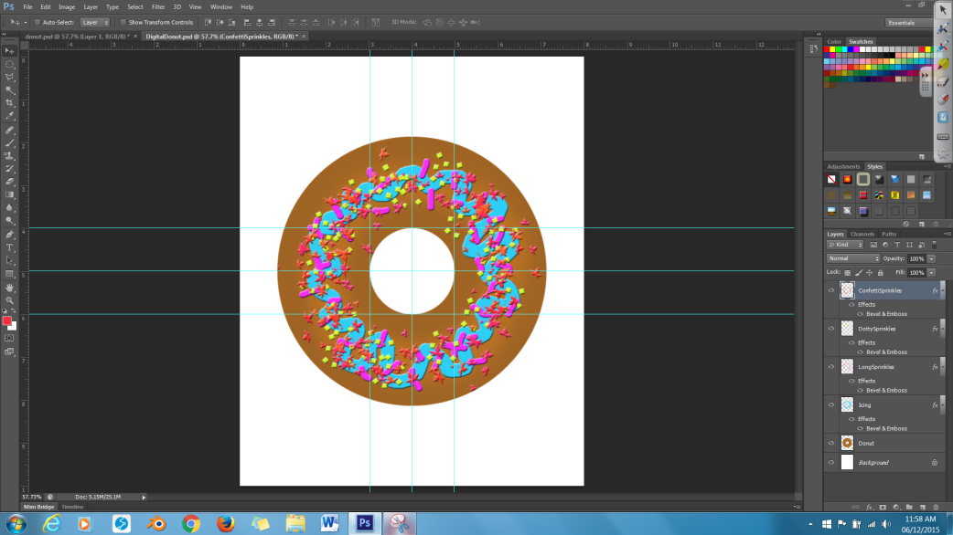

Note: If your “marching ants” selection goes away, use the Magic Wand Tool to select the background (transparent pixels). Shift click on the center hole to add it to the selection. Right-click on the selection, and then click “Select Inverse” to select the opposite of what is currently selected.

Note: Make sure that you have selected the correct layer before you tell Photoshop to make a change. This is the #1 troubleshooting suggestion when something will not work.

Part 5: Moving the Donut

You may not need to do this step, depending upon how you wish to organize the other elements of your advertisement.

- Link the Layers: Soon, we will add text to our document – but to do that, we need to move our donut (and all it’s layers) closer to the top of the document. To make all our layers come along during this move, Shift-click each layer, except for the Background layer, then click the Link icon (1st from the left, looks like a chain) at the bottom of the Layers Panel to link the layers together.

- Move the Donut: Select the Move Tool, and move the donut, along with all its toppings, to the upper canvas.

------------------------------------------------------------------------------------------------------------------------------
Part 6: Adding a Background

- Select Inverse: Select the “Donut” layer then select the Marquee Tool. Right-click on the current selection (the donut shape), and select “Select Inverse” to select the white background. Press delete to delete the background.

- Deselect: Right-click on the current selection and select “Deselect.” Now, nothing on your Canvas should be selected.

- Add a New Layer. Name it “Background.” Drag this new layer to the bottom of your Layers Panel, and Make sure it is selected.

- Choosing a Gradient: Select the Gradient Tool (this may be hidden inside the Paint Bucket tool). In the Options Bar, customize a gradient you would like to add to the background of your donut.

- Adding the Background: With the Gradient Tool still selected, draw a line from one edge of your canvas to another to apply your chosen gradient. Where you draw the line determines how your gradient will look.

------------------------------------------------------------------------------------------------------------------------------
Part 7: Adding Text

- Select the Text Tool. Use the default horizontal type tool setting and choose various text options such as formatting, colour, and alignment. At the top of your document, type in a title for your bake shop. At the bottom of your document, type in a slogan/advertising ‘spiel for your bake shop.
  - Note: You do not need to create a New Layer for Text, since it automatically creates its own layer.
  - To edit text, make sure the Text tool is selected, then click on the text you want to edit. Be careful not to accidentally add a new text layer altogether!

- Warp the Text? For added interest, you can add the “Warp Text” option to your title by going to the Options Bar (with the Text Tool selected), and clicking on the Create Warped Text icon (T on an arc). Select whichever option suits you.

- Add Layer FX? For even more interest, you can add Layer FX to your text. Go to the Layers Panel, then the Styles Panel. Select whichever style best suits your donut and background.

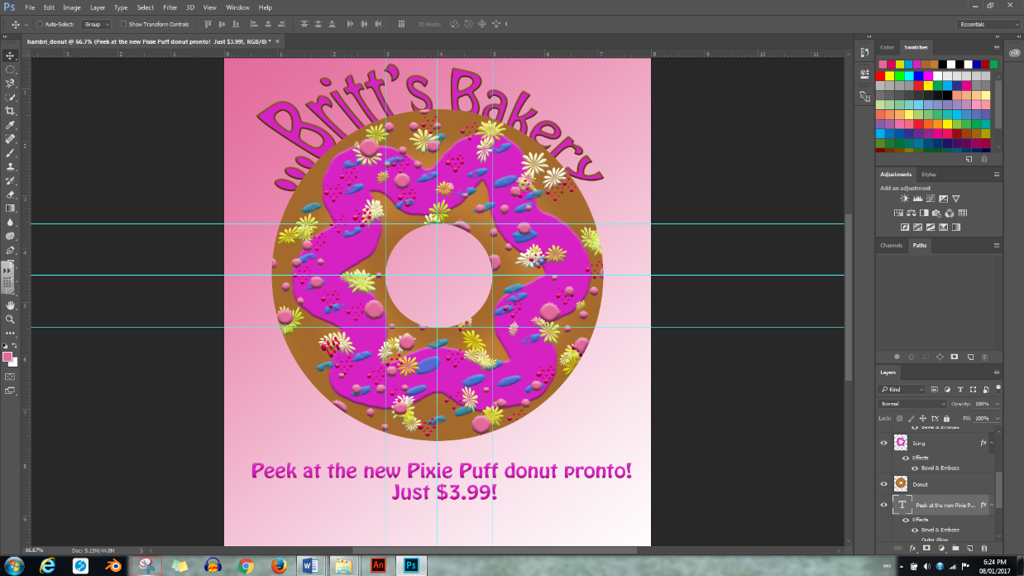

------------------------------------------------------------------------------------------------------------------------------

Part 8: Adding a Drop Shadow

Give your donut an even more 3D look by adding a drop shadow.

- Select the “Donut” layer.

- In the Layers Panel, select Layer FX > Drop Shadow… When the Options pop-up opens, set the Distance to “20 px” and the Size to “20 px.” Click OK.

------------------------------------------------------------------------------------------------------------------------------
Part 9: Cleaning Up the Document

It is best practise to clean up your document, whenever possible. This will reduce your file size, and help keep you organized.

- Add a Layer Group: Create a new layer group by going to your Layers Panel and selecting the “Create a new group” folder icon in the bottom of your Layers Panel.
  - The location of the New Group depends on which layer you had selected when you created the New Group. This is not a problem, since groups, like layers, can be moved up and down the Layers Panel.

- Re-Locate Your Layer Group: Name your new group “DonutToppings,” and move it above the “Donut” and the 3-4 “Toppings” Layers to the top of the Layers Panel.

- Open your Layer Group: Open the DonutToppings group by clicking on the tiny white triangle beside the DonutToppings group folder.
  - You may only add Layers to a Group if the group folder is open.

- Add Layers to the Group: Add your Donut, and Toppings layers to the Group by dragging them up towards the Group one-by-one (when you drag up, a highlighted line will appear between the layer you are dragging and the one above). If you have successfully placed a layer within your group, it will become slightly indented under the Group folder.

- Minimize the Group: Minimize the Group’s contents by clicking the tiny white triangle beside the Group.

- Do the same thing for your all your Text.

- Clear Your Guides: Go to the Menu Bar, and select View > Clear Guides.

- Deselect Your Donut: You already know how to do this.
  - Although the guides and selections do not print, it is a good idea to look at your final product to make sure it looks good without the guides.

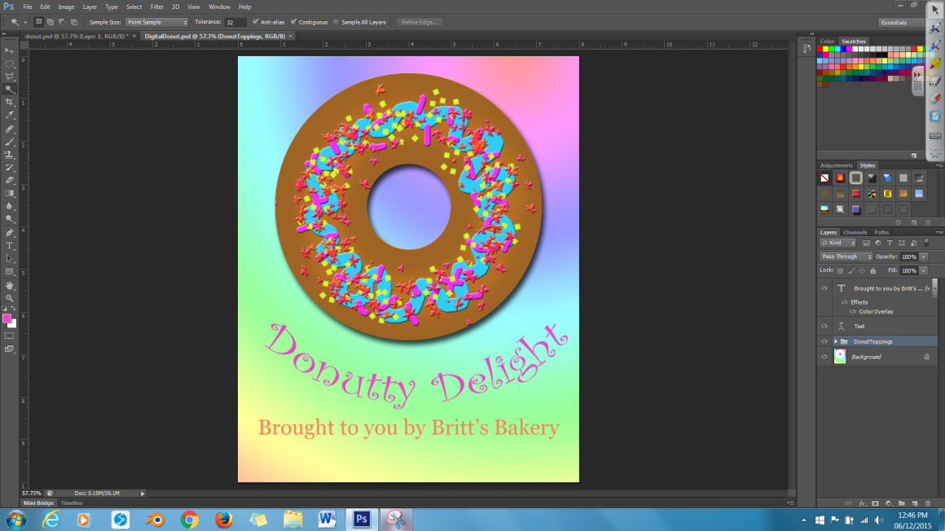

------------------------------------------------------------------------------------------------------------------------------

Save your “Donut” document, then open DigitalDonut_Tutorial2

