Aspect Ratios, Sizes & Applications
Applying what you’ve learned

Grab a digital camera. Turn it on, and find the “menu” or “functions” button. Scroll through the menu options until you find a heading that deals with “Image Size.” Multiple size options will be listed in this menu. Here are some of the common size indicators:
- Aspect Ratio – 1:1 (square), 4:3 (standard), or 16:9 (high definition/widescreen)
- Relative Size – S (small), M (medium), or L (large)
- Size in Pixels – 2304x1728 (4 megapixels), 3264x2448 (8 megapixels), or 4608x3456 (16 megapixels)

Think Back: According to what we’ve learned in class, is it a good idea to take original photos using a larger or smaller size setting?

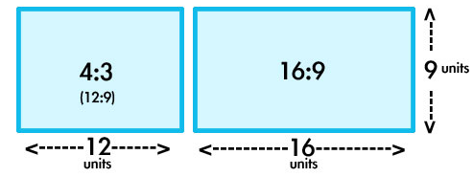
Aspect ratio is a way to measure how many pixels WIDE an image is vs. how many pixels HIGH an image is. For example, if your image has an aspect ratio of 4:3, that means it is 1 unit wider than it is high. Thus, your image would look like a short, fat rectangle. If your image has an aspect ratio of 16:9, that means that it is 7 units wider than it is high. Thus, your image would look like a longer, thinner rectangle.

An aspect ratio of 4:3 is the most commonly used in digital photography, while an aspect ratio of 16:9 is most commonly used in video and video display (computer monitors and televisions). This can be tricky when it comes to resizing your photographs for web or print usage! Use the reference chart below as a guide.

4:3 Aspect Ratio | Image Size | 16:9 Aspect Ratio
128 x 96 | Very Small  ~1/10 screen | 160 x 90
160 x 120 | Small  ~1/8 screen | 200 x 112
320 x 240 | Small-Med  ~1/4 screen | 400 x 225
425 x 320 | Med-Large  ~ 1/3 screen | 533 x 300
640 x 480 | Large  ~1/2 screen | 800 x 450
960 x 720 | Extra Large  ~3/4 screen | 1200 x 675
1280 x 960 (Ms. Hammond’s computer monitor)  or  1600x1200 (standard def TV/computer monitor) | Entire Screen | 1600 x 900 (school computer monitors)  or  1920 x 1080 (high def TV/computer monitor)
3262 x 2448  (= 8 megapixels)  *In JPEG form = ~3 MB | Larger  than Screen | 3768 x 2120  ( = 8 megapixels)  *In JPEG form = ~3 MB
Now, apply what you’ve learned by adjusting your camera to the appropriate size settings, and resizing your Basic Composition 1 Photographs to a size that is suitable for your website.
Why is this relevant to you?
As you already know, the larger your file size, the more of your computer’s memory it uses up. The more of your computer’s memory it uses up, the slower your computer will perform.

The same thing happens with websites! Websites are all about SPEED – isn’t it frustrating when you try to visit a site and it takes FOREVER to load? One of the major causes of slow loading times is large image files. To prevent this from happening on your Weebly digital portfolio, you must take the large, high-quality images you take for your class assignments and resize a copy of each so that it is more appropriate for web use.

How do you do this?
You can do this with ANY photo editing program (online web 2.0 editing tools, Photoshop, Corel)… but honestly, Paint is the easiest to use! It is simple, but mighty. Here’s what you need to do:
- Open Paint (search it up from your Start menu)
- Choose File (blue tab) > Open… and navigate to where you saved your 6 CompBasics1 images
- Open the first image
- Adjust the zoom (in the bottom right-hand corner) so that your entire image is displayed on the screen
  - Note: The image appears so large because it contains more pixels than your screen!
- At the top of your window, click on “Resize”

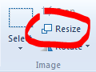

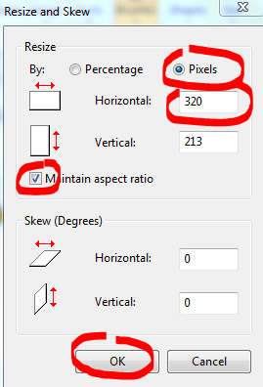
- Choose the “Pixels” (“Percentage” is chosen by default) radio button, make sure the “Maintain Aspect Ratio” box is checked, and change the “Horizontal” input to “320.” Your Vertical input will change automatically to keep the proportions of your photo balanced! Depending on what aspect ratio your camera is set to, your Vertical input number might be a little different than the number in the table above. That is OKAY!
  - This will give you an image that takes up approximately ¼ of your computer screen when displayed on a Weebly website, and creates a much smaller file size than the original
- Click the “Okay” button!

- Choose File (blue tab) > Save as… (DO NOT simply click SAVE – otherwise it will save over your beautiful, big, versatile original). Add the word “resized” to the end of the photo’s name and click “Save.”
- Repeat these steps for your other 5 photos!

What are some tools that can help you calculate your aspect ratio?
Here are some Online Aspect Ratio Calculators that can help you figure out what size to make your images:
http://andrew.hedges.name/experiments/aspect_ratio/
http://calculateaspectratio.com/

