7 Elements of Short Stories/Fiction

Fiction is all about using the seven elements of fiction creatively, and authentically. We want our reader to be interested and engaged in our stories, and without the use of the 7 elements of fiction (conflict, plot, setting, character, style, point-of-view, and theme), this is very difficult to do! Think about when we tell someone a story about our day:

- Without PLOT there would be no story at all.
- Without CONFLICT the story would not be interesting!
- Without a developed CHARACTER nobody would be interested (think of the times you’ve told stories about random people who nobody knows but you)!
- Without SETTING the stage of the story, nobody could picture where it takes place.
- Stories are all about perspective. POINT of VIEW influences how we tell the story and which details we include.
- THEME is the whole reason we tell our stories! What is the point?
- Without STYLE, our stories would be hollow and impersonal.

The difference between non-fiction and fiction:
Non-fiction is all about the world, while fiction is about a world.

Something else to keep in mind: How we write fiction differs from how we write nonfiction. Both fiction and nonfiction have a beginning, middle, and end – BUT the way in which we structure these differs greatly!

In non-fiction…
Our beginning is our introduction, where we straight up TELL the reader what is going to happen later on in our writing. The middle is our body, which details specific arguments or points we want to make about our subject. The end is known as the conclusion, where we summarize our arguments and/or points and re-inform the reader of what we are trying to say.

In fiction…
Our beginning does NOT tell our reader exactly what the story is about (if it did, then what would be the point of reading and/or listening to it?!). Rather, it establishes the conflict, setting, and characters. The middle of our story tells our reader HOW the conflict and characters came to be, how the characters deal with the conflict, and how the characters came to be (this is also known as the PLOT). The end of the story is where the resolution of the conflict takes place. It is where we find out what happens to the characters and what the point of reading the story was!

SO what ARE the Elements of Short Stories/Fiction, anyways?
1. Conflict: The major problem faced by the characters in the story.

- Conflict is essential to plot; without conflict there is no plot.
- In a short story there is usually ONE major conflict (though there may be several additional minor conflicts)
- There are 2 Types of Conflict:
  - External: A struggle with a force outside oneself
    - Eg. another person, an event, society, nature
  - Internal: A struggle within oneself
    - Eg. making a decision, overcoming emotion, resisting an urge
- There are 4 Forces of Conflict:
- Human (vs. human): Physical or verbal conflict in which the protagonist struggles against another human being.
- Nature (vs. human): Physical or emotion conflict in which the protagonist struggles against the forces of nature (Eg. weather, water, survival)
- Society (vs. human): Social conflict in which the protagonist struggles against ideas, practices, customs or beliefs of other people.
- Self (vs. human): Psychological conflict in which the character struggles with him/herself (Eg. soul, ideas, right vs. wrong, physical limitations, choices)

2. Plot: What happens in the story/sequence of events that develops the author’s main idea

- The short story usually only has ONE plot so that it can be read in one sitting
- The plot satisfies natural human curiosity about what happened – the more artful the plot, the more satisfying the relief from the reader’s itch of curiosity!
- There are 5 Elements of Plot
  - Exposition – Contains the initiating event (an idea or action that sets the story in motion) and an introduction to the characters, setting, and conflict are revealed. It is also when you want to hook your reader!
  - Rising Action – The internal response (the protagonist’s reaction to the initial idea or action wherein he/she attempts to set a goal or solve a problem). This is when things start to get complicated and the reader gains a full understanding of the conflict present within the story.
  - Climax – The attempt (the protagonist’s efforts to achieve a goal or overcome a problem). It occurs when the presentation of the conflict ends, and the resolution begins BUT it is not the resolution itself. This is the highest point of interest, and the turning point in the story. The reader is meant to wonder: will the conflict be resolved or not?
    - The climax is 3-Fold
      - 1) the protagonist receives new information
      - 2) the protagonist accepts this information
      - 3) the protagonist acts on this information
  - Falling Action – The consequence (the action or state of affairs that occur as a result of the protagonist’s success or failure). When the complications begin to resolve themselves, and the reader KNOWS “what happens next.”
  - Resolution – The reaction (an idea or event which expresses the protagonist’s feelings about his/her success or failure which relates the events in the story to some broader set of concerns). This is the final outcome of the story, where the conflict is either resolved or not, and where the reader can understand the purpose of the short story.

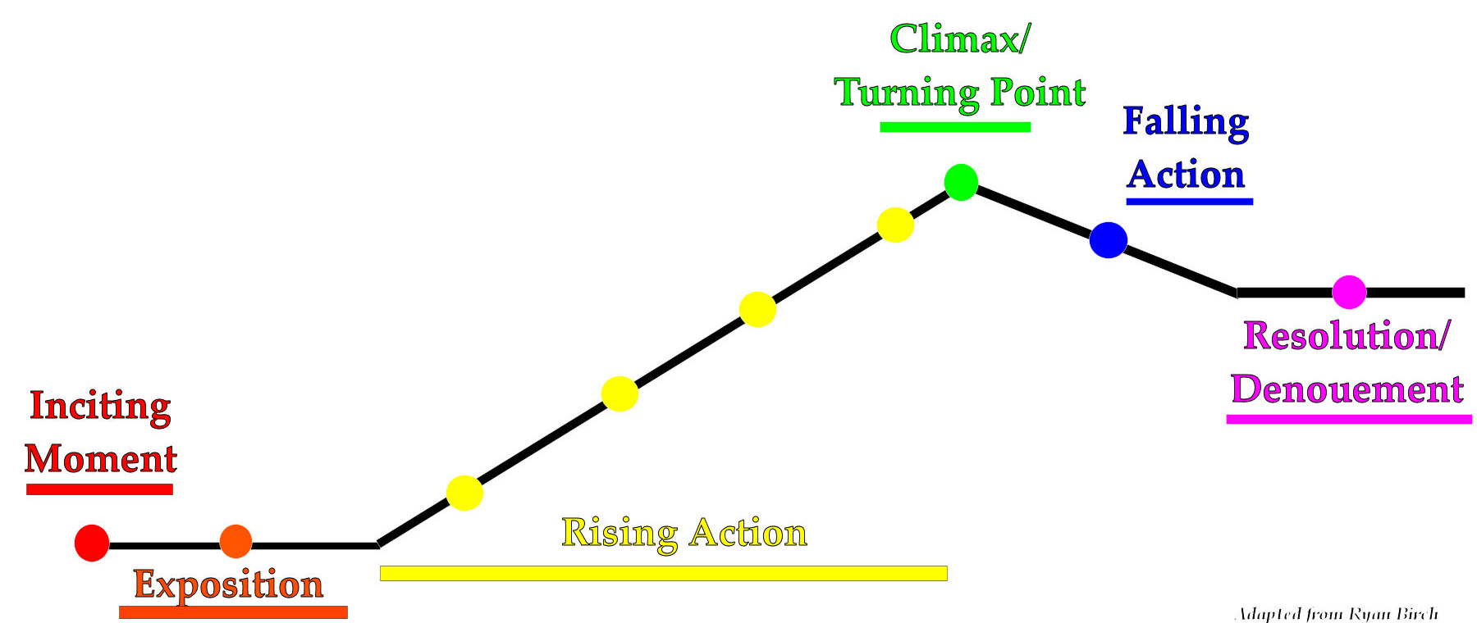

3. Setting: The time and location in which the story takes place

- For some stories setting is extremely important for plot, while for others it is not
- BUT even in the stories which do not require setting for their plotline, setting is important in developing a vivid picture of what is happening in the reader’s mind
- There are Several Types of Setting:
  - Physical: Where the story takes place (eg. Brandon, MB or Ghana, Africa)
  - Geographical: What the setting looks like (eg. mountainous, oceanic, jungle-like)
  - Temporal: The specific time at which the story takes place (eg. morning or afternoon)
  - Historical: When, in history, the story takes place (eg. 1800s, 1970s, 2060)
  - Social: What the daily lives of the characters in the story are like (speech, clothing, mannerisms, customs, culture)
  - Political: What types of governing bodies exist in the story (eg. dictatorship, democracy… this matters if writing about things like the Holocaust or Civil War)
- It is also important to consider the mood created within a short story. What is the feeling the reader gets from reading parts of the story? Is it bright and cheerful or dark and frightening?

4. Character: Has 2 meanings: 1) the person/people within the story; 2) the characteristics of the person/people within the story

- There are FEW characters in a short story (to avoid confusion/incomplete development)
- There are 3 Titles of Characters:
  - Protagonist: Main character that is perceived as likeable by the reader
  - Antagonist: Character that opposes the main character and is perceived as dislikeable
  - Secondary Characters: Characters that interact with the protagonist to further plot. In short stories, secondary characters are usually not well-developed.
- There are 2 Types of Characters:
  - Rounded/3-D: Well-developed characters that possess many different aspects and emotions, and complex personalities that can be found in real people. These characters exhibit change/growth within the story.
  - Flat/Static: Poorly-developed characters that are presented briefly and possess only a few character traits. These characters are often stereotypes used to illustrate the points and ideas, necessary for plot progression and demonstration of theme. They do not exhibit change.
- Character Characterization: Characters must be well-rounded, consistent, motivated, and life-like to be convincing. Believable characters follow the Character ABCs:
A. Appearance (build, facial features, clothing etc.)
B. Behaviour (actions, activities, moods, relationships, mannerisms, speech)
C. Character (moral aspects, thoughts, feelings, dreams)
- Characters may be Revealed in 2 Ways:
  - Expositorially: The author tells us what the character is like, or has other characters tell us what the character is like
  - Dramatically: The author has the reader make inferences about what the character is like, based on the character’s actions (what they think, do, or say)

5. Style: Use of literary techniques to convey meaning within text

- Authors use various stylistic techniques to enhance the meaning of their stories, to make the message of their stories easier to understand, to allow the reader to make connections between different texts and everyday experiences, and to make their stories memorable
- There are 5 Major Categories of Stylistic Techniques:
- Structure: Refers to the form of a text
    - Includes: form, plot structure, sentence structure, flashbacks
- Register: Refers to the words and language used within the text
    - Includes: diction, syntax, voice, tone
- Sound: Refers to the sounds created by language patterns within the text
    - Includes: rhyme, rhythm, repetition, alliteration, assonance, onomatopoeia

- Figurative Language: Refers to the manipulation of language within a text
    - Includes: metaphor, simile, idioms, personification, symbolism, allegory, imagery, hyperbole
- Irony: Reversal of expectations used for a humorous or emphatic effect
    - Includes: verbal irony, situational irony, dramatic irony
    - Verbal Irony: When the speaker says the opposite of what he/she intends
      - Eg. Alphy, who is a cop, arrogantly tells Gary, who is a serial killer, that Gary wouldn’t know a criminal if he was right in front of him
    - Situational Irony: When a character’s actions have an effect that is opposite from what was intended, so the outcome is opposite of what was expected
      - Eg. Ermintrude takes a step backwards to avoid getting hit by her brother’s water gun, and falls into a swimming pool
      - Eg. While Rob is robbing a bank, his getaway car gets stolen
      - Eg. Esther marries Randolph because she believes he is rich, and during the bachelor party, Randolph loses all his money
    - Dramatic Irony: When the reader knows something important that the characters are not aware of
      - Eg. The reader knows Juliet is alive, but Romeo believes she is dead, so he commits suicide. If Romeo had known that Juliet was alive, the story would not have nearly the same power.

6. Point of View: The perspective from which the story is told; the person telling the story

- The person telling the story is referred to as the narrator
- There are 3 Perspectives of Narration:
  - First-Person: The story is told by the protagonist.
    - It uses first-person pronouns: “I,” “me,” “we.”
    - There is 1 Type of First-Person Narration:
    - First-Person Participant: The character is involved in the action, so their view of events is limited to what this one character experiences or sees. The reader only knows and responds to what this character tells them.
    - First-person stories give readers a strong sense of intimacy, of being close to the characters and the events. In our initial responses as readers, we usually become most sympathetic to the first-person narrator.
  - Second-Person: The story directly addresses the reader.
    - Uses second-person pronoun: “you” throughout the entire story.
    - This type of narration is not typically used in short stories (except in Create-Your-Own-Adventure books), and is more commonly used in instructional manuals etc.

  - Third-Person: The story is told by a narrator who is outside the action of the story. It uses third-person pronouns: “he/she,” “his/hers,” “they.”
    - There are 2 Types of Third-Person Narration:
- Third-Person Omniscient: The narrator is “all-seeing” and has the ability to move from character to character, and event to event, having free access to characters’ thoughts, feelings, and motivations. This narrator is able to introduce information where and when he/she chooses, although their personal interpretation/opinion is generally not offered.
- Third-Person Limited Omniscient: The story is told by a narrator outside the action, but from the viewpoint of only one character in the story. This point of view allows the narrator more freedom than first-person participant, and creates unity within the story, since the narrator can move easily between describing action and reporting selected thoughts and feelings.

7. Theme: The basic idea/central point, and the author’s reason for writing the story

- Themes are the “body” of short stories, and the other 6 elements of fiction are the “organs” that make it possible for the body to exist and to function.
- Generally, themes are statements and opinions about morals, human nature, social order, popular culture, or other hotly contested topics
- Some Examples of Themes:
  - Things are not always as they appear
  - People fear change
  - Peer pressure is wrong
  - Don’t judge a book by its cover
  - Family is the most important aspect of life
  - Revenge is costly
  - Knowledge is dangerous, ignorance is bliss
  - Nature is more powerful than man
  - Technology destroys humanity

It would be a GREAT idea to keep this booklet for the rest of high school ELA! You will need to know this stuff for your final exams in grades 9-12!

