Film Strip Tutorial

Follow the steps below to create your very own vintage film strip from scratch. Note: Some steps have been cut out of this tutorial (hence the jump from Step 9 to Step 15, for example) to make it more streamlined and simple. If you would like to see these missing steps, simply click on the hyperlink included in this document’s footer.

Step 1 – Getting Set Up
To create a filmstrip, we will use an original filmstrip for the dimensions. For this tutorial I will use cm (centimeters) for my dimensions.

Create a new document:
- Width = 20 cm
- Height = 5 cm
- Resolution = 300 pixels/inch
You can always make the image smaller NEVER bigger, so start big.

In this tutorial we’re going to make use of guides. We want these to be in cm so use CTRL+R to show the rulers. Right click somewhere on the rulers and select Centimeters.

Set up guides by clicking on the vertical or horizontal ruler and dragging, or by selecting View > New Guide… (for more precise positioning). Set up the following guides:
- Vertical: 0.5 cm and 19.5 cm
- Horizontal: 0.75 cm and 4.25 cm

Step 2 – Create the Strip
Make sure you have black as your Foreground and white as your Background color. Note: You should also have the Shape’s Stroke and Fill colors set to black.

Grab the Rectangle Tool and create the rectangle needed for the filmstrip shape between the guides you created. Rename this layer “FilmStrip.”

Step 3 – Set up for the Sprockets
We need two more guides:
- Vertical: 0.6 cm
- Horizontal: 0.95 cm (see where using View > New Guide… can come in handy?)

Now make the sprockets (the little white bits around the edges of the strip): Grab the Rounded Rectangle Tool and, in the Properties Panel, under the Options (the little black arrow on the left side of Radius) change this to Fixed Size and the dimensions to 2mm and 3mm (width and height). Use a radius of 3px.

Click once inside the overlap of the guidelines and change the Stroke and Fill colors to white. Rename this layer “Top Sprockets.”

Step 4 – Multiplying the Sprockets
We need another guide line:
- Vertical: 19.4 cm

Now here’s the tricky part, so pay attention and read carefully!

Zoom in for a better view, then:
- Choose the Path Selection Tool (the little black around under the Text tool)
- Click on the rounded rectangle you just made
- Press CTRL+ALT+T (free Transform)
- Press and hold the ALT and SHIFT then mouse click in the rectangle
- Drag the shape slightly to the right.
- Press the ENTER key on the far right side of your keyboard (NOT the one under the backspace, but the one in your Numpad).
- Press CONTROL+ALT+SHIFT+T 39 more times and see what happens. (Transform again command) Make sure you have 40 white little rounded rectangles.
- Press the same ENTER key again.

Step 5 – Align the Sprockets
The next thing we are going to do is align the rounded rectangles. With the Path Selection Tool, click on the last rectangle (in my case number 40). Press and hold the SHIFT key, now click and drag the shape to where it hits the overlap of the guidelines on the right side of the image. Shift-select all of the Sprockets.

Step 6 – Evenly Distribute the Sprockets
In the Properties Panel, click on the Path Alignment option, then choose “Distribute Widths,” and see what happens! Isn’t this great?

Step 7 – Duplicate to Create the Bottom Sprockets
Another guideline is needed to position the bottom sprockets:
- Horizontal: 4.05 cm

Let’s copy the sprockets to the bottom: Duplicate the Top Sprockets layer (either right-click the layer in the layers panel to duplicate, or select all the sprockets and press CTRL+J). Rename this new layer “Bottom Sprockets.”

Make sure that the Bottom Sprockets layer is selected, and that the move tool is selected. Now hold down the arrow key (pointing down) to move the bottom sprockets to the bottom guideline.

Step 8 – Set up the Frame Dividers
It’s time for the frame dividers. This time we need 4 more guidelines:
- Horizontal: 1.35 cm and 3.65 cm
- Vertical: 4.1 cm and 4.35 cm (approximately – this might differ, depending on how your film strip looks. Basically, you want to create a frame divider between the 8th and 9th sprockets!)

Step 9 – Create the Frames
Use the Rectangle Tool to make a rectangle shape using the guides we just created. Name this layer “Frames.” With the same technique we used to multiply the sprockets, copy and move the shape. Here is a reminder of the steps you should follow:
- Choose the Path Selection Tool (the little black around under the Text tool)
- Click on the rectangle you just made
- Press CTRL+ALT+T (free Transform)
- Press and hold the ALT and SHIFT then mouse click in the rectangle
- Drag the shape slightly to the right, where it snaps to the guideline
- Press the ENTER key on the far right side of your keyboard (NOT the one under the backspace, but the one in your Numpad).
- Press CONTROL+ALT+SHIFT+T 3 more times and see what happens. (Transform again command) Make sure you have 5 white rectangles all evenly spaced and aligned. If this is not the case, move them around by hand OR use the “Distribute Widths” button from Step 6.
- Press the same ENTER key again.

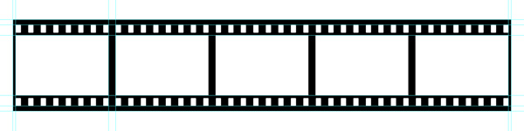

Step 15
The last thing we need to do is to add some photos.

Open a photo you like in Photoshop and press CTRL+A (this will select to whole photo), then press CTRL+C (to make a Copy). Go back to the filmstrip and press CTRL + V (to Paste the photo onto a new layer). Resize the photo so that it fits within the first frame. Do this 4 more times and the filmstrip is done! Be sure to rename each photo layer.

Feel free to add some funky filters, or make adjustments to your images to liven up your filmstrip
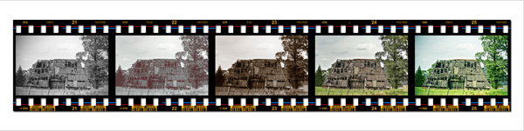

Final Step – Save Your Work
Save your file as “DP_Filmstrip_YourName.” Keep it – who knows when you might use it in another piece of Photoshop work!

