Final Assignment: Graphic Short Story
Unit 3: Not-So-Short Stories

Overview
Your Job: Combine ALL 7 elements of fiction together to generate, plan, and transform your ideas into a graphic short story. You may use www.pixton.com, the Comic Life program, or plain old pencil and paper. Your story should be between 8-12 panels in length (approximately 2 pages). You will have approximately 7 classes to complete this project from beginning to end. Keep it simple.

PART 1: Planning Requirements:
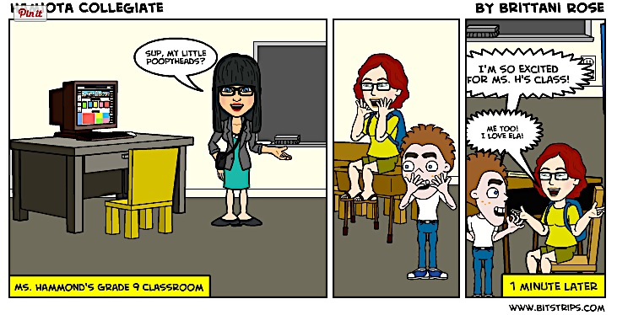
- Review some examples of award-winning graphic short stories to determine what design, formatting, and organizational techniques this form uses to tell a story
- Identify your 5 writing variables
- Complete the “Story Map” planning sheet (pencil/paper)

PART 2: Product Requirements:
- Organization and Formatting:
  - Have a relevant, and interesting title
  - Take the form of a graphic short story
  - Have between 8-24 panels (2-4 pages) – I recommend between 10-12
  - Utilize panels, narrative captions, speech bubbles, thought bubbles, sound effects
  - Colour and/or shade your panels
- Content and Ideas:
  - Include all 7 elements of plot
  - Follow the basic plot diagram: Exposition-Rising Action-Climax-Falling Action-Resolution
- Stylistic Elements:
  - Incorporate at least 1 (the more the merrier) element of style into your story. Consider: symbolism, dramatic irony, situational irony, sensory details, dark humor, foreshadowing, dialogue, or onomatopoeia

PART 3: Revising Requirements:
- Character – Did you cover all your ABCs?
- Plot – Are all 5 elements of the plot diagram clear and detailed?
- Conflict – Do you have at least one developed and exciting conflict?
- Setting – Did you use descriptive details to describe your setting (temporally/physically/geographically/historically)?
- Theme – Does your story have an important message?
- Point-of-View – Is your story told from 1 consistent point-of-view?
- Style – Did you include at least 1 interesting stylistic element?

Rubric: The Graphic Short Story
 | Numerical Feedback  (0-5) | Descriptive Feedback  (words)
/05 Planning (3.2.5)  - Writing Variables are identified  - Story Map is thoroughly developed  - Story Map includes # of panels per plot point | 5 x 1  =  /5
/10 Organization & Formatting (4.1.2, 4.1.3)  - Story has an interesting & relevant title  - Story is between 8-24 panels (2-4 pages)  - Story follows formatting conventions of graphic short story (panels, bubbles, images, etc.)  - All panels are coloured and/or shaded | 5 x 2  =  /10
/10 Content & Ideas (4.1.1, 2.3.2)  - Story follows all 5 elements of the plot diagram, in order and in detail  Story has a thoroughly developed and engaging…  - Plot  - Conflict  - Characters  - Setting  - Theme | 5 x 2  =  /10
/05 Stylistic Elements (4.2.4)  - At least 1 stylistic element has been attempted; element enhances the story’s idea and mood  - Point-of-view is consistent and well-suited to the story’s plotline | 5 x 1  =  /5
Final Comments:

Total Mark: ____/30 =____%

Congratulations

You’re a regular Robert Munsch.

I hope you enjoyed writing this story as much as I enjoyed reading it.

