The Four Basic Principles of Design
GOOD DESIGN IS… complimentary and cohesive

Contrast – Unless they are exactly the same or similar, make the separate elements on your page very different.
Repetition – Repeat visual elements (color, shape, texture, spatial relationships, size) to create cohesion.
Alignment – Line elements up in a way creates straight lines, and enhances readability and organization.
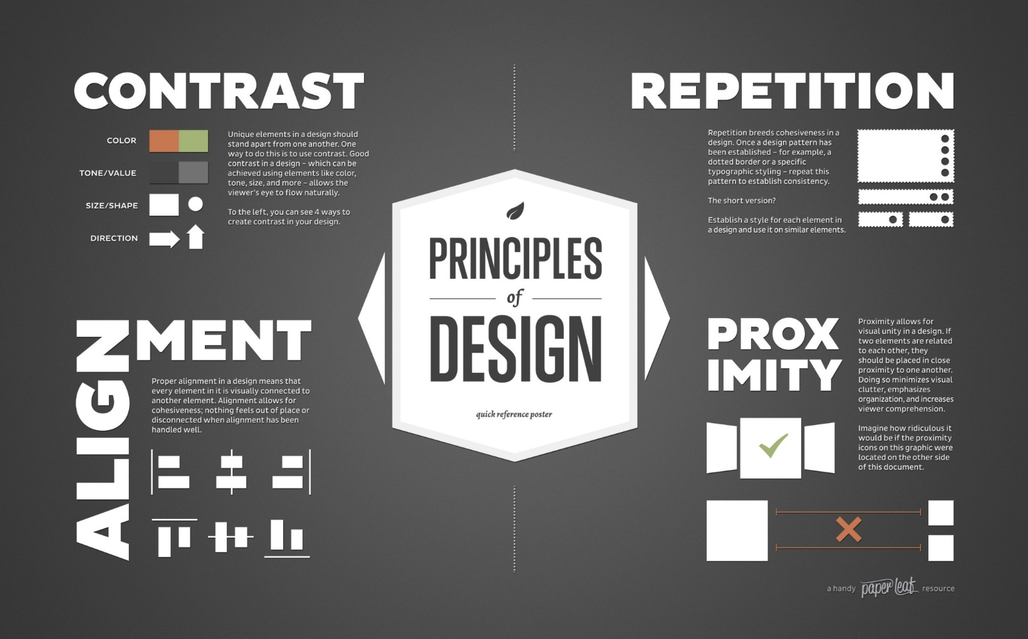
Proximity – Related items should be closer together, non-related items should be farther apart.
Common Design Offenses:
Long lines of text that require deep reading
Lack of contrast (everything is one colour, size, etc.)
Bright and hideous backgrounds (make it tough to read)
Lack of consistency (constant contrast)
Too many graphics (get distracting)

