Part 1: Text-Text Connections
Choose one of the stereotypes you brainstormed in Mean Girls: Part 2, then find a form of media that helps portray this stereotype to a teenage audience. Remember: Media can be many different things – advertisements, commercials, websites, social media, television, movies, articles, and news networks to name a few! Once you have found your media source, complete the following boxes:
Replace with chosen stereotype
One common teenage stereotype is…

Not only is this stereotype portrayed by the movie, Mean Girls, but it is portrayed by…
Replace with name of media
[add a hyperlink to the source & right-click > change picture below]

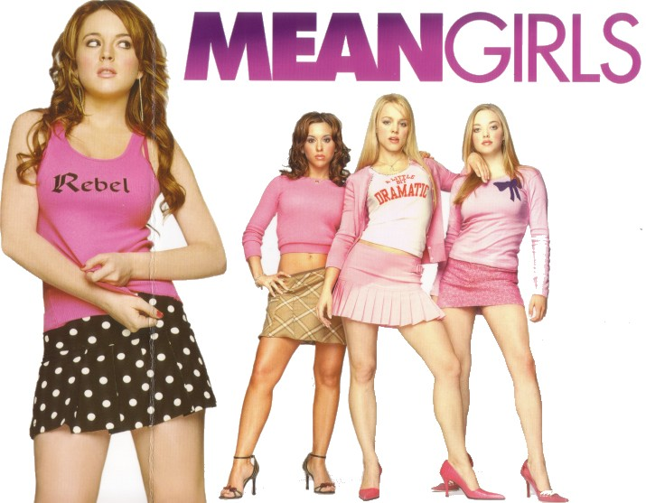

…as well, because:
Replace with an explanation of how the stereotype is portrayed in your media text and what type of influence (positive or negative) this has on the media’s audience.

