Assignment: The Memoir
Grade 11 English

As you know, “purpose” is one of the five writing variables. In fact, it may even be the most important; if we don’t have a purpose for the things we do, why do them at all? Memoirs are a special form (another writing variable, btw) because they have multiple purposes. They must both entertain and reflect.

- To Entertain: Strong memoirs pique our interests and awaken our emotions. Some make us laugh out loud, while others cause us to tear up. The memoir is a hybrid between fiction and nonfiction; it is often referred to as “creative nonfiction” because it contains all the elements of storytelling, yet it is based on true events.
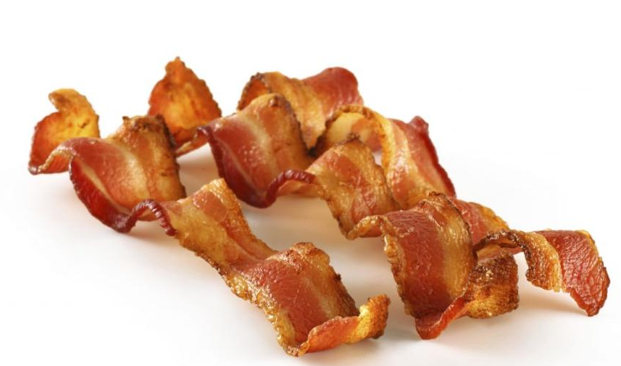
- To Reflect: The best memoirs tell us about impactful and meaningful experiences, such as losing a loved one, failing at something important to us, or overcoming obstacles to achieve our goals. But they do more than simply tell the story. They include our thoughts about the story – why it came to mind, why it is relevant and interesting to our audience and, most importantly, what influence it has had on our life (be it a lesson learned, a change in our perspective, or a change in our behaviour). Answer the questions, “What makes your story worth telling?” and “So what?”

Choosing a topic:
- Focus your topic: Unlike an autobiography, a memoir focuses in on particular moment (or element) in your life, rather than touching upon your entire life.
- Some elements to consider: People, places, ideas, beliefs, experiences, events, day, moments, relationships, pets, activities, etc.

Organizing your ideas:
- Just like all writing, a memoir must have a clear beginning, middle, and end. Generally speaking, your memoir should have an introduction that introduces the character(s), setting, and future conflict. Your middle will explore your central idea in detail (and, in most cases, in chronological order) in the form of a story. Your ending is where you conclude, and reflect upon, your story.
- You have a lot of freedom in this form of writing. You may choose to structure your ideas a little differently than what is explained above, and that is OK – as long as it comes out making sense. You might choose to include literary techniques such as: flashbacks, flashforwards, foreshadowing, cliffhangers, red herrings, suspense, or dialogue.

Sharing your voice, and perspective:
- Write from your point-of-view, using either past (easier) or present (tougher) tense.
- Voice is how writing feels to someone when they read it. It is the expression of the writer’s personality through the words they choose. Are you formal or casual? Friendly or standoffish? Calm or flighty?
- Your voice also sets the tone for your written piece. Tone is the author’s attitude towards the subject he/she is writing about, and also towards the audience (eg. playful, sarcastic, solemn, condescending, angry, etc.). Tone is different than mood (which is the general vibe that encompasses the reader).

Choosing effective language:
- Memoirs are meant to bring a story to life in the reader’s mind. As such, the amount of detail present in the memoir should resemble that which you would find in fiction…which is a lot!
- Use strong, juicy, and interesting verbs, adverbs, and adjectives to help describe your characters’ actions, thoughts, environment and emotions – and cause your reader to feel those emotions, as well
- Write using imagery or, words that appeal to five senses (touch, taste, smell, sight and sound)
- Don’t be afraid to include some figurative language (similes, metaphors, personification, onomatopoeia, hyperboles, alliteration, allusion, metaphors, etc.)

Having trouble getting started? Start…
- At the beginning of your memory:
  - When I was a little girl, my grandpa used to make me bacon every day.
- With a fact about your memory:
  - Until the time I was 12, bacon was my favorite food.
- With a glimpse of your memoir’s ending
  - As a child, all I knew about bacon was that I adored it. I had no idea that when I grew up, I would come to view bacon not only as a symbol of my childhood, but as a symbol of my culture, as well.
- With drama and suspense:
  - I was mid-flight over the Atlantic Ocean, and I knew I couldn’t make it much longer… It had been 552 hours since my last fix, and my body was raging with the symptoms of withdrawal. If I wasn’t first in line for a B.L.T. at the Winnipeg Airport Timmy’s, I was going to snap.
- With a vivid description:
  - I ran through the office door of my grandparent’s motel, and scrambled onto the humongous easy-chair in front of the television, simultaneously flicking the channel to Treehouse. I leaned back in my chair and took in the delicious smell of salty, savory bacon wafting through the air.
- With an important quote:
  - I can vividly remember him saying “Oh Lori, it’s good for her. It’ll put hair on her chest.” I can’t describe to you how many times he used to say this exact phrase when defending my baconous (yes, this is a fictional word) diet to my concerned mother.
- By asking a question:
  - What would life as a Canadian child be without bacon?

