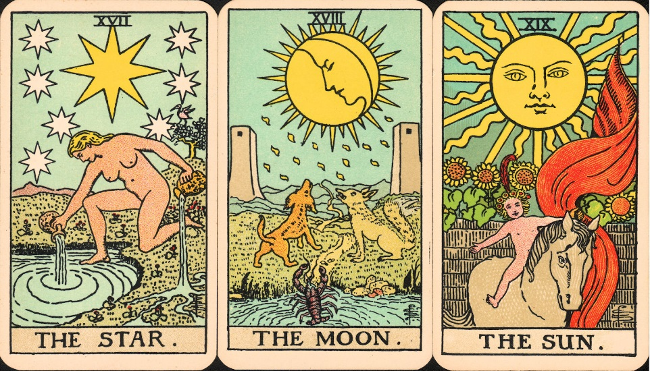
Night
Assignment: Tarot Card

During your study of Elie Wiesel’s Night, you took part in a variety of mini-lessons that focused on four of the core literary devices within the English Language:
- Figurative Language (metaphor, simile, personification, hyperbole)
- Foreshadowing
- Symbolism
- Theme

What is this assignment all about?
For this assignment, you will need to choose 1 of the devices listed above, then create a double sided Tarot Card that depicts a powerful example of how this device is used within the novel. You may decide to use the same device you chose to write down on your sticky note during the mini-lesson, but remember: you will be assessed on the overall impact the example you choose has on the novel.

What is a Tarot Card?
Tarot cards come in a deck of 56-78. They are a form of divination used by fortune tellers and psychics to help people predict their future in areas such as career, love, and quality of life.

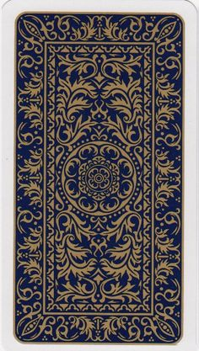
What must my Tarot Card include?
On the Front of the Card:
- A word/phrase that sums up your specific device
  - Ex. if I chose the symbol “night” I would write “Night” at the top of my tarot card
- Quote from the novel where the device is used
  - Ex. “Never shall I forget that night, the first night in camp, that turned my life into one long night seven times sealed”
- Visual (coloured or shaded) representation of your device
  - Ex. a black background with an Auschwitz barrack in the bottom corner filled with dimly-lit starts, and a single, final star falling in the direction of the barracks
On the Back of the Card:
- Explanation of what your device represents within both your quote, and the novel, as a whole.
- Continuation of the visual representation around the border or your card

What do I need to do now?
- Choose a device
- Think about what this device represents within the novel, and why it is important/impactful
- Find a specific example (a quote) from the novel that showcases your chosen device
- Complete your tarot card (front and back)

