Assignment: Literary Essay
Of Mice & Men

The Question:
Choose a theme from the novel Of Mice and Men. What important message do you think the author, John Steinbeck, is trying to communicate about that theme? Consider the characters’ actions, reactions, relationships, conflict, experience, and growth throughout the novel.

Breaking Down the Question:
- Choose a theme (Friendship, Loneliness, Power, Discrimination, the American Dream, other).
  - This will act as a starting point from which you will focus your essay.
  - Since themes often overlap or are very-closely related to one another, you may find yourself writing about a combination of themes.

- Decide what you think Steinbeck is trying to say about that theme.
  - This will become your thesis, or Statement.
  - To help you with this, think about all the different times in the novel when your chosen theme is brought up. Then think about all the things these times have in common/in difference. Are any characters’ actions, reactions, relationships, or experiences repeated? Are they very different from one character to the next? Do they change from the beginning of the novel to the end?

- Record all the reasons why you think that.
  - This is going to become your evidence, or your Explanations and eXamples.
  - To help you with this, record certain events from Of Mice and Men (as you watch the film) that support your thesis, then skim through the novel to find the page number that each event occurs on. Gather as many reasons as you possibly can, then choose the 3 strongest ones to turn into the paragraphs in your essay’s body. You will write abbreviated versions of these 3 reasons in the “roadmap” of your thesis.

- Reflect on what this message says about Steinbeck’s view of human nature and/or life during the great depression, overall.
  - This is going to become your concluding statement, or your whY your response matters.
  - To help you with this, decide whether or not Steinbeck’s message about your chosen theme is positive or negative. Next, decide what events in the real world might inspire him to feel this way. Here is where it is a great idea to make a text-world, text-text, or text-self connection.

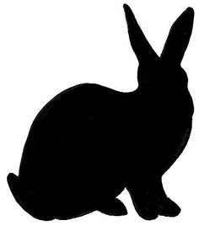

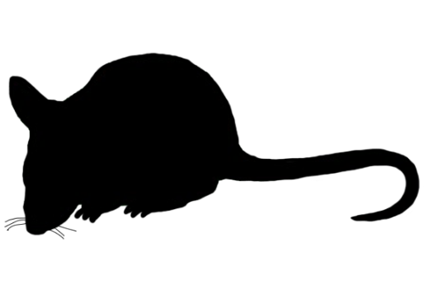

Examine Some Examples:
Remember the Found Poem we did for Lamb to the Slaughter’s themes?

Theme: Murder

Thesis: Dahl suggests that sometimes it is okay to murder someone, as long as they deserve it

Roadmap (Evidence): This is made clear to the readers because they are made to feel sorry for Mary Maloney, they are given a backstory about how her husband did something very bad to her, and ultimately, she is not punished for her actions at the end of the story.

Concluding Statement: Mary Maloney is not alone in her murderous actions. Many of television’s most famous modern-day “good guys,” such as Dexter’s Dexter, take the law into their own hands and kill the “bad guys” without any sort of punishment, which suggests that maybe Dahl is not alone in his murderous thoughts.

Theme: Appearances

Thesis: One of the most important messages in the story is that people are not always who they appear to be on the surface.

Roadmap (Evidence): …Dahl shows this through the change in Mary Maloney’s mannerisms and appearance, treatment of her husband, and overall behaviour from the beginning of the story to the end of the story.

Concluding Statement: In the 1950s, around the time when this story was published, women were viewed as delicate, mindless housewives, which is very much the way Mary Maloney is described at the beginning of the book. By the time the story is finished, however, Mary is described as a powerful, intelligent single woman, proving that the way women are viewed because of their appearances (their gender) has little to do with who they are, and what they are capable of.

Your Turn:
Using the information and examples discussed in class, develop an idea for your own essay about Of Mice and Men. Try to fill out as much of this document as possible BEFORE viewing the film. Then, as you’re viewing the film, think about how you could make your responses even better. AFTER viewing the film, revisit this document, and fine-tune your idea.

- Theme (Power, Friendship, Loneliness, Discrimination, American Dream): Replace this text with your theme

- Thesis (What is the novel’s main idea about your chosen theme?): Replace this text with your thesis

- Body of Evidence (How do you know that?):
  - Replace this text with your evidence
  - Replace this text with your evidence
  - Replace this text with your evidence
  - Replace this text with your evidence
  - Replace this text with your evidence

- Concluding Statement (How does your thesis connect or relate to a broader context, like your life, another text, or the world around you): Replace this text with your concluding statement

