Pivot Stick Figure Animator
Activity #1: The Basic Ball

Your Task: Create an animation of a ball falling from above. Make the ball bounce off the ground, then roll down the ramp.
- The tough part of this assignment is making the ball fall and bounce off the ground with a natural arc and angle. To help you with this:
  - Look up “bouncing ball arc animation” on Google or YouTube
  - Partner up and model what it looks like to bounce a ball for one another
  - Slow down, or speed up your animation so that it looks natural

Settings: Change your screen size so that is set to 800x600 (widthxheight) pixels.
- You can do this by clicking the “options” tab at the top of the window.

Setting the Stage: To animate a ball, you’ll have to delete the stickman and create a new figure type
- Click on the default stickman on your stage, then click the “delete” button on the left-hand side
- Select “file” “create figure type”
- Create a circle by clicking on the circle icon then click-dragging on the existing “stick’s” yellow dot
  - Note: To delete the default “stick” that appears in the create window, after drawing your circle click on the stick, then on the red x button (you may need to enlarge your window)
- Select “file” “save as.” Name this file “ball.”
- Click “file” “load figure type,” then select the “ball” file.

Background: Load the “RampBackground” file from Ms. Hammond’s “Hand Out” folder
- How to load background in Pivot Stick Figure: File Load Background
  - Make sure that the “files of type” is set to “jpeg,” not “btmp”
- Location of “Hand Out”: Shared Drive Hammond Hand out 2D Animation

Length Requirement: 2-3 seconds

Saving: Create a folder within your Animation Folder called “loginname_PivotStickFigure” Save your pivot as both a working file (.piv) and a GIF (.gif) file inside this “loginname_PivotStickFigure” folder. Once you have completed all 3 Pivot Stick Figure activities, you will hand a copy of this folder in to Ms. Hammond’s Hand In folder.

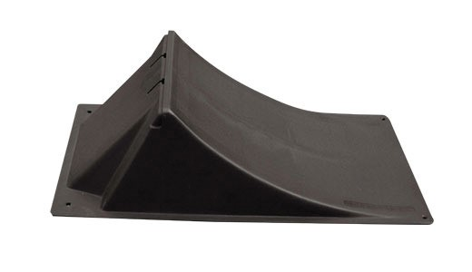
Checklist for Success:
- Screen size = 800x600
- RampBackground picture has been added
- Animation is between 3-5 seconds long
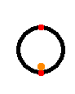
- Bounce arc is smooth
- Roll on ramp is believable
- Animation has been exported as a GIF (.gif)

