“The Survivors of Auschwitz”
RTTQ Question
Background Information: On January 27, 2015, four of the thirteen child survivors depicted in the original Soviet Army photo taken after the liberation of the Auschwitz concentration camp met in Krakow, Poland, for the 70th anniversary of their liberation.
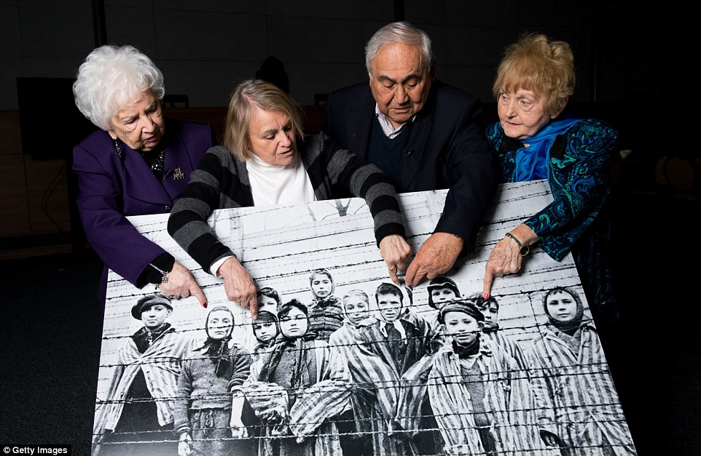

Analyze how the visual elements (colour, size, space, depth, line, expression, body language, detail, etc.) within the photo work together to convey an idea or create an overall impression.

Replace this text with your response [note: your response should be no longer than ¾ of a page, double-spaced].

