STOP-MOTION ASSIGNMENT: Editing
Bringing it all Together in Movie Maker (NOT Windows Movie Maker)

GETTING STARTED
- Navigate to your computer’s “://D” drive (when working with video projects, and large files in general, it is a good idea to work directly on your computer’s hard drive, rather than on a network drive).
- Inside, create a new folder called “loginname_stopmotion.” You need only use one group member’s login name. I know who is with who.
- Save everything you use for this project inside this folder, including images, background music, narration, and the exported MPEG-4 video.
  - Note: You will have to use this same computer each class you spend working on this project, since the D-drive belongs to that specific computer.

ADDING IMAGES
- Open Windows Movie Maker. Click the “File” (blue button) tab in the top left corner, then choose “Save Project As.” Name your project: “loginname_stop-motion.” Choose the “loginname_stopmotion” folder in your “://D” drive as your save location.
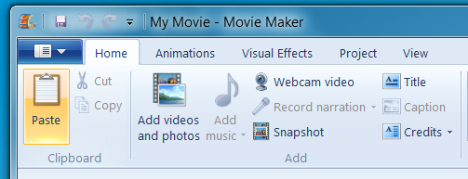
- Click “Add videos and photos.”
- In the pop-up window, navigate to the “://D” drive where your photos are stored.
- Select all the photos (shift+click, shift+A, or click and drag a box)you want to use for your stop-motion animation (hint: it helps if you organize these by naming them 1, 2, 3, 4… etc. before bringing them into Movie Maker) and click the “Open” button to bring them into your workspace. If you need to rearrange any of your photos once they’ve been added to your workspace, simply click and drag them around.
- Select all the photos in your workspace at once (shift+click, shift+A, or click and drag a box). This is very important – otherwise, not all photos will be affected by the changes in Step 8.
- Click on the “Video Tools Edit” tab at the top of the Movie Maker window.
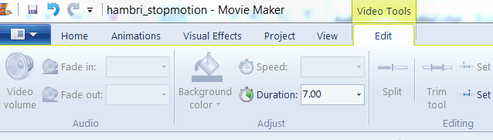
- Near the top of the window, change the “Duration” to 0.07. This will cause your animation to occur at a rate of approximately 15 frames/second (1 second/15 = 0.067).
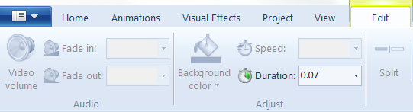
- Save your project.

ADDING TITLES, CAPTIONS & CREDITS
Add a title slide (at the beginning), captions (during; optional) and credits (at the end) to your stop-motion animation! This is a great way to frame your story.
- Click on the “Home” tab at the top of the Movie Maker window.
- Place your cursor on the timeline where you would like to add a title/caption/credit, then click whichever option you would like to add! Click on the new frame that is added to your timeline to edit the text. Make sure that you change the duration of title frames and credits so that they don’t only stay on the screen for .07 seconds (you wouldn’t even be able to read it)!

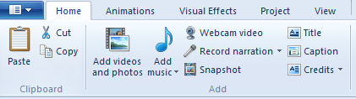

ADDING BACKGROUND MUSIC
Before adding background music or sound effects to your Movie Maker project, you must first find and download your audio. To do this, choose a link from Ms. Hammond’s class website. Once you’ve found some audio you like, download it to your “loginname_stopmotion” folder in the “://D” drive.
- Click on the “Home” tab at the top of the Movie Maker window.
- Click “Add music” then “Add music.”
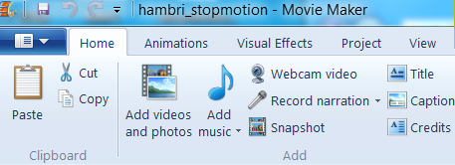
- In the pop-up window, navigate to the folder where your audio is stored.
- Select the audio you wish to use in your project and click the “Open” button to bring it into your workspace. The audio will automatically align itself with your images. It will appear as a green track below your images.
- To fade your music, choose the “Music Tools Options” tab at the top of the Movie Maker window.
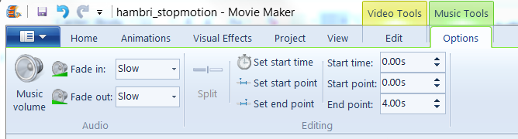
- You can now set the Fade In speed, and the Fade Out speed and Volume, as well as the Start and End times.
- Save your project.

ADDING NARRATION
- Plug your microphone (ask Ms. Hammond for one) into one of the USB ports on your computer.
- Make sure that your curser is aligned where you want your narration to begin.
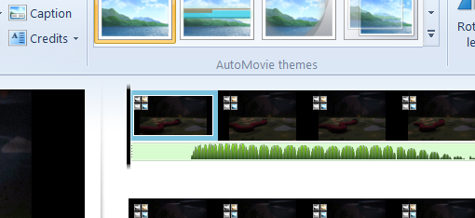
- Click on the “Home” tab at the top of the Movie Maker window.
- Click the “Record narration…” button. You may be prompted to select your audio device from a drop-down list. If your microphone does not show up, you may need to close and reopen Movie Maker.
- Click the red “Record” button in the top left corner to begin recording. Press the blue “Stop” button in the top left corner to stop recording.
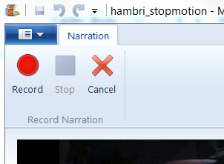
- A pop-up window will appear, prompting you to save your recording. Name it “narration” and save it in the “loginname_stopmotion” folder in your “://D” drive.
- The narration will now appear as a yellow-grey track below your images.
- You may find that you need to re-record your narration quite a few times to get it just right. To do so, simply click on the old narration track then press delete. Repeat steps 18-21, saving overtop of your old “narration” file, until your narration sounds the way you want it to.
- Save your project.

EXPORTING YOUR VIDEO
- Click on the “Home” tab at the top of the Movie Maker window.
- In the top right corner, click the “Save movie” button
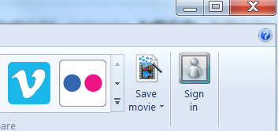
- Name is “loginname_stopmotion” and save it as an MPEG-4/H.264 Video file. Save it to the “stopmotion” folder within your “://D” drive.

