Assignment: Top Ten Pieces of Advice
For High School Students

Congratulations – you’re near the end of your high school careers! But, what if you weren’t? What if you had to go all the way back to grade 9 and do it over again? Is there anything you would do differently? Is there anything you would do the same?

Last semester, a whole new class of students at NACI crossed over to the high school side of things. As veteran high-schoolers, it is your job to give them some advice – 10 pieces (minimum), to be exact. Take some time to reflect on the type of person you were in grade 8. Think about your goals, thoughts, dreams, and fears. Were you excited to go into grade 9 or were you nervous? And now, after you’ve left grade 8 and progressed through grades 9, 10, and 11, was high school what you thought it would be?

In a new Word document, created a rough draft by jotting down and explaining 10 pieces of advice you would give students about to enter into high school. These pieces of advice can be on a variety of topics - anything from schoolwork to sports, from parents to part-time jobs, from rebellion to relationships, and everything in between. But be specific.
Examples to Get You Thinking:
- Stretch your brain: take at least 1 class that scares you!
- Don’t be afraid to ask for help.
- Build strong relationships with your teachers.
- Avoid older boys.
- Volunteer your time – it makes you feel good, and it looks great on a resume.
- Document your high school years (make a scrapbook, write a journal).

Once you’ve composed your rough draft, you will create your good copy in the form of a blog post (using your Weebly website, create a new “Blog” page and, in your page layout, indent it underneath your Unit 1 page), which will be read by some of this year’s grade 9 students.

Consider Your Audience:
- The people you are writing for are approx. 14 years old. Therefore, they are practically children.
- While it is okay to be casual and colloquial with them, it is not okay to talk to them the way some of you would talk to your friends (swearing, vulgarities, discussing mature subject matter). Your objective is to help, not to harm, offend, or disrespect.

Title: The title of your post should contain the words “10 Pieces of Advice,” but is otherwise up to you.
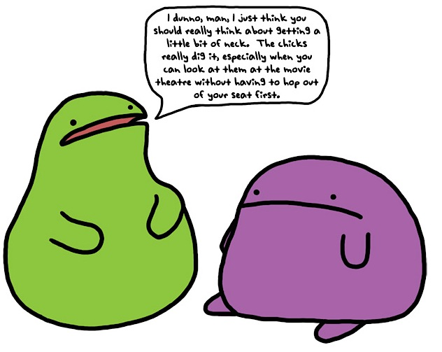
Format: You may format your list however you’d like,
providing you stick within the confines of the blog post.
Again, in terms of readability, be sure to consider your audience.

Mechanics: Everything on your list must be proofread
carefully for spelling, grammar, and syntax. This does not
necessarily mean that you may not use strategic
misspellings or slang. Consider your audience.

Follow These Steps:
- Create your rough draft (in a Word document)
- Have me approve it before blogging
- Create your good copy on your Weebly Blog
- Feel free to browse your classmates’ blogs and comment on their posts!

