Urban Playground Photo-Op Part 3: BoyWithBowtie Image
You’ve been contacted by Urban Playground magazine, a magazine that specializes in helping parents keep their kids active and engaged in a positive way within the confines of a city setting. The editor-in-chief heard you could use some practise with your photo-editing skills, so she’s sent this week’s photos your way.

Using the images provided in the UrbanPlayground_Tutorial file (Shared > Hammond > Hand Out > Digital Pictures > UrbanPlayground_Tutorial), follow along with the mini-lessons below.

Skill 1: Evaluate
Open Photoshop CS6, then open the BoyWithBowtie_Before photo, and the BoyWithBowtie_After photo. If you’ve done this correctly, they will appear as separate tabs at the top of your document window. Save each photo into your Photoshop folder.

Evaluate the “BoyWithBowtie_Before” photograph. Notice how, when you zoom into the photo, the boy’s teeth are a little yellowed. Also, the image is noisy (it looks a little choppy and blurry), and a shadow is covering a good portion of the boy’s face. The photo is also in full colour, and for this little fellow, Urban Playground magazine has a more artsy image in mind. Now take a look at the “BoyWithBowtie_After” photograph. Much better, isn’t it?

For the lessons that follow, edit the BoyWithBowtie_Before photo, and use the BoyWithBowtie_After photo as a reference for what your photo should look like when you’re done!

Before making any adjustments, rename the “Background” layer “BoyWithBowtie.” It is always best practise to name your layers after their content.

------------------------------------------------------------------------------------------------------------------------------------------

Skill 2: Teeth Whitening
Hue/Saturation Adjustment layers can be used to provide a variety of different functions when it comes to recolouring your photographs. In the step-by-step below, you will learn how to manipulate some of its less commonly used sliders.

Step-By-Step
Goal: Apply and adjust a Hue/Saturation Adjustment layer to whiten the model’s teeth.
- Use the Quick Selection tool to make a selection of all of the model’s teeth.
- Feather the selection by going to the Menu and selecting Select > Modify > Feather. Change the number in the feather box to 1 or 2 to blur the edges of the selection. Click OK.
- Click the Hue/Saturation adjustment layer button to add an adjustment layer to the photo.
- In the Hue/Saturation dialog box, click the drop-down menu that is currently set to Masters, and select Yellows.
- Click and drag the Saturation slider slowly to the left to remove the yellow in the teeth (try dragging it all the way to the right for a yucky effect)!
- From the same drop-down menu, select Masters again.
- Drag the Brightness slider slowly to the right to brighten the teeth (a natural amount).
_____________________________________________________________________________________

Skill 3: Noise Reduction
Random, extra pixels that aren’t part of the image, and that cause the image to look fuzzy, are referred to as “noise.” Noise can result from scanning, from using a high ISO setting on a digital camera, from underexposure, or from shooting in darkness with a long shutter speed. To help correct this issue, Photoshop contains a “Reduce Noise” Filter that you can apply to noisy photographs.

Step-By-Step
Goal: Apply and adjust a Reduce Noise Filter to make the entire photograph clearer
- Zoom in on the boy’s face, to approximately 300%, to be exact. This will allow you to see the changes while you adjust the filter’s settings.
- Select the BoyWithBowtie layer
- From the Menu Bar, select Filter > Noise > Reduce Noise.
- In the dialog box that pops up, do the following:
  - Increase the strength to 10
  - Increase Preserve Details to 30%
  - Increase Reduce Colour Noise to 80%
  - Move Sharpen Details to 30%
- Click Ok to apply the changes or Cancel to exit out of the pop-up menu
  - Click Ctrl + Z to undo the filter. This will allow you to see the difference between the original photo and the change you just made. Go to Edit > Step Forward to reapply the Reduce Noise Filter.

_____________________________________________________________________________________

Skill 4: Conversion to Black and White
Just like with any other colour adjustments you wish to make in Photoshop, there are two ways of converting a photo to Black and White: 1) Destructive Editing (going to the Main Menu > Image > Adjustments > Black & White) or 2) Non-Destructive Editing (going to the Layers Panel > Adjustments > Black & White). It is best practise to use adjustment layers so that changes can be made to your project later on, therefore, we will be using Adjustment Layers in this tutorial.

Step-By-Step
Goal: Apply a Black & White Adjustment Layer to make the photo Black & White, rather than coloured.
- Make sure that your BoyWithBowtie layer is selected.
- In the Layers Panel, click the Black & White Adjustment Layer
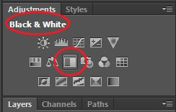

- In the popup window, click and drag any of the color sliders to vary the intensity of the grays. Once you are happy with the color levels, click the tiny “x” in the right-hand corner to close the popup window. Your changes will be applied automatically.
  - Note: If you ever want to change the settings for an adjustment layer, simply click on the adjustment layer’s icon inside your Layers Panel.
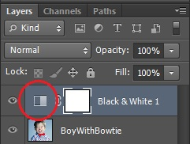

- NOTE: In the future, if you want to TINT your image, simply check the Tint box inside the popup window, and click the color swatch that appears to choose a color with which to tint your image.
_____________________________________________________________________________________

Skill 5: Adding a Pop of Colour
There are several ways to add a pop of colour to a photo in Photoshop. Two common ones are through 1) Destructive Editing (duplicating your colour photo – one on each of two layers, changing the top layer to black and white and leaving the bottom layer coloured, then erasing through the black and white layer to reveal the colour underneath), or 2) Non-Destructive Editing (using a layer mask to reveal the colour in the original photo). Both ways will be discussed in this tutorial. Choose either way!

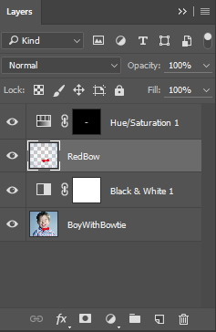
Step-By-Step: The “Destructive Editing” way (easier but less practical)
Goal: Highlight the boy’s bowtie by revealing its red colour (the rest of the image remains uncoloured).
- In your Layers Panel, duplicate your “BoyWithBowtie” layer. Rename the “BoyWithBowtie copy” layer you just created “RedBow.” Move the “RedBow” layer above the Black/ & White adjustment layer in your layers panel (so that the black and white adjustment isn’t applied to it).
- With the “RedBow” layer selected, use the Quick Selection tool to select the boy’s bowtie.
- Go up to the menu and choose Select > Feather and change the feathering to 3.
- Right-click on the bowtie you’ve selected, then choose “Select Inverse.”
- Use the Eraser tool (make your brush size very large) to erase the entire layer! Since you have left your bowtie out of the selection, it will not be erased, but will instead remain on the layer above the Black and White Adjustment layer so that the bowtie appears red!
OPTIONAL: Change the colour of the bowtie by selecting it and using the Brush combined with the Hue option to paint overtop of it.

Tip: It is always a good idea, when using destructive editing, to keep a copy of the original photo on its own layer at the bottom of your stack. This way, if something goes wrong, you always have an unedited copy of the photo.
Step-By-Step: The “Layer Mask” way (harder but more practical)
Goal: Highlight the boy’s bowtie by revealing its red colour (the rest of the image remains uncoloured).
- In your Layers Panel, select the Black & White Adjustment Layer. More specifically, click on the white cube (aka the layer mask) so that it has a white outline around it.

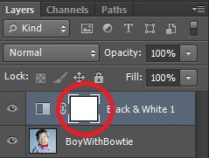

- At the bottom of your Tools Panel, click the Switch Colors icon to reset the Color Picker to Black (foreground – aka top color) and White (background – aka bottom color).
  - Remember: Black conceals, white reveals. Since we have the “Black & White” Adjustment Layer selected, we are actually going to be using the Black paint colour to conceal the Black and White Adjustment.

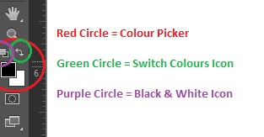

- In the Tools Panel, select the Brush tool.
- In the Options Menu, do the following:
  - Click the Brush picker drop-down, and select a soft-edged (aka feathered) brush. This will ensure that your color selection will look natural around the edges.
  - Set your Opacity to 75%. This will give you a fairly strong colour, but will also allow the details beneath the bow (the wrinkles, shadows, etc.) to show through.

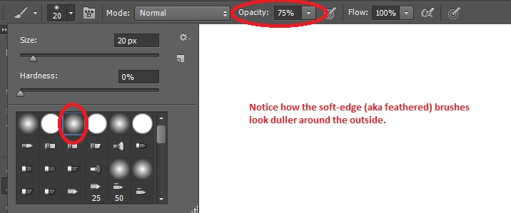

- Use the brush to paint overtop of the bowtie. As you paint, the bowtie should turn from black to red! This is because you’re masking part of the Black and White Adjustment Layer as you paint.
- TIPS FOR PAINTING USING A LAYER MASK:
  - Run your brush overtop of an area multiple times to increase the redness of the bow
  - If you mess up and “color” part of the picture you weren’t supposed to, click on the Switch Colors icon to switch your foreground color to white, then paint over the area you would like to “uncolor.”
OPTIONAL: Change the colour of the bowtie by applying and adjusting a Hue/Saturation Adjustment Layer to the image.

_____________________________________________________________________________________

Skill 6: Adjusting Shadows
To bring out the detail in the dark or light areas of an image, you can use the Shadows/Highlights command. Note, this is a Destructive Editing command.

Step-By-Step
Goal: Lighten up the shadows covering the left side of the boy’s face
- Make sure that your BoyWithBowtie layer is selected.
- In the Main Menu, select Image > Adjustments > Shadows/Highlights. Notice that Photoshop automatically applies the default (autocorrect) settings to your image.
- In the popup menu, do the following:
  - Change the Shadows to 25%
  - Change the Highlights to 5%
  - If you are happy with these results, click OK to apply the changes.

