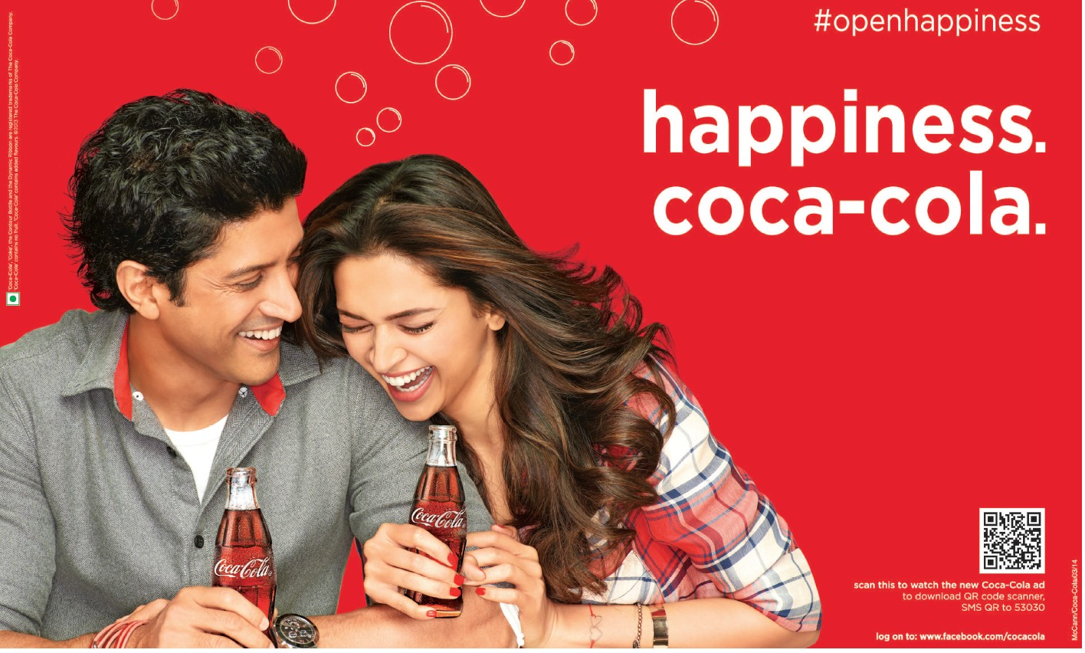
Visual Elements: A Cheat Sheet

Central Idea: Drinking Coke helps you have fun, be happy, and build great relationships.

ELEMENT | EXPLANATION | EXAMPLE
Color  *The combination of red, blue and yellow | - Used to represent feelings/ideas  - Consider: hue (actual color), shade (brightness/darkness) harmony (similarity) and contrast (difference) | The bright colours (shade) could represent happiness and liveliness. The red (hue) color could represent passion and love between the two characters. Both characters are wearing outfits that have similar colours (harmony) – the boy has a red collar and bracelet, the girl has a red shirt and nail polish – which could represent a close relationship between them.
Line  *Two connected points | - Used to represent connections or divisions  - Consider: position of line (horizontal, vertical, looped), look of line (straight or curvy), width of line (thick or thin) | The curved (look) lines of the bubbles found in both the coke and the background could represent the playfulness happening between the characters. The fact that the lines make circles, which are never-ending loops (position) could mean that the characters’ relationship will be long-lasting. The lines of the bubbles are thin (size), which might mean that they are easily breakable (width), but the lines of the letters in “happiness” are thick (width), which could mean that even though the bubbles in the coke are strong, the happiness that sharing a Coke creates will last a long time.
Space  *Dimensions of height and width within a page | - Used to show how closely related (or far apart) elements within the image are related  - Consider: blank vs. filled space, proximity (how close or far apart elements are) | The two characters inside this image are positioned very close together (proximity), which might mean that they have a very close relationship with one another – they could be good friends, or even boyfriend/girlfriend. There is quite a bit of blank space on the right side of the image so that it is the two characters, and the story they tell, that draw the eye first.
Size  *Height and width of an element | - Used to show importance  - Consider: bigger (more important) vs. smaller (less important) elements | The largest part of the image is the two characters, which shows that they are the most important part of the image. This tells me that the most important think drinking Coke can do is bring people together. The smallest part of this image is the copyright and “further viewing” information, which tells me that this is not as important as the message about happiness and relationships communicated by the two characters.
Balance  *Distribution of weight, proportion, or amount of details vertically and horizontally | - Used to show relationships between elements; balanced elements show equality, and imbalanced elements show inequality  - Consider: details, color, amount of elements, size | The two people, and the two bottles of Coke are approximately the same size, which shows that they are equally important. There is more detail on the left side of the image than there is on the right, which shows that the left side is more important.
Repetition  *The same or similar elements appearing multiple times | - Used to show importance and/or unity (elements working together to communicate an idea)  - Consider: colors, words, details, lines | The color red is repeated very often throughout the image, which could mean that the feelings that red represents (passion, liveliness, love) are very important to the image’s central idea. In addition to red, white is also repeated a lot. Red and white are the colors of the Coca Cola brand, which reminds the viewer that it is COKE that is responsible for causing the relationship between the two characters.
Detail  *The small parts that, when combined, make up an element or idea | - Used to, when combined together, form a bigger idea  - Consider: amount of detail, characters (facial features, age, gender, race, class, clothing, etc.), actions, emotions (facial expression, posture, interactions), sightlines (where they are looking), objects/props, setting (time and place) | There are not a lot of small details inside the image, which allows its message to be communicated clearly. The facial expressions and body language of both characters show that they are happy – both are smiling and laughing, which means they are having a great time together. They are also holding Coke, which shows me that the reason they are having a good time is that they are drinking Coke. The characters are young adults, one is male and the other is female, and they both appear to be middle class, judging by their average-looking clothing. This could mean that Coke is right for many different types of people (male and female) but especially young adults. There is no clear setting in this image, which tells me that the setting one drinks Coke in isn’t important – it can be enjoyed at any time in any place.
Focal Point  *The element that first draws attention | - Used to show importance  - Consider: color, size, contrast (difference), framing (lines that surround an object, like the frame of a picture), level of detail, outlining | The focal point, or most important part, of this image is the two smiling/laughing characters drinking Coke. They stand out because their detail contrasts the plain background, they are the largest part of the image, they are made up of multiple colors (instead of just red like the background), and they are framed by all the plain, white text in the image.

